Investigating Emotional Granularity with Music

A thesis presented by

Fahim Ahmed

to
the Faculty of the Committee on Degrees in Neuroscience
in partial fulfillment of the requirements
for the degree
of Bachelor of Arts

Harvard University
Cambridge, Massachusetts
March 2025

Neuroscience Concentration

Division of Life Sciences

Harvard University

The Harvard College Honor Code

Members of the Harvard College community commit themselves to producing academic work of integrity – that is, work that adheres to the scholarly and intellectual standards of accurate attribution of sources, appropriate collection and use of data, and transparent acknowledgement of the contribution of others to their ideas, discoveries, interpretations, and conclusions. Cheating, plagiarizing or misrepresenting the ideas or language of someone else as one’s own, falsifying data, or any other instance of academic dishonesty violates the standards of our community, as well as the standards of the wider world of learning and affairs.

Digital Signature:_______________________________________________________

ACKNOWLEDGEMENTS
Thank you to my mentors in the MIND Lab and PINE Lab—Nick Kathios, Dr. Psyche Loui, and Dr. Laurel Gabard-Durnam—for all of your help in designing, developing, and accomplishing this thesis—something that I never could have dreamed of writing. Psyche, you never cease to inspire me with your own passion and drive within the intersection of music and neuroscience. Nick, this thesis would not have been possible without you. From first time I hopped on a Zoom while sitting at a piano in a practice room to talk about joining the MIND Lab in Fall 2023 all the way up until now, you have seen me through countless revisions and roadblocks, rescheduled meetings, and panicked Slack messages, and I am so grateful for all you’ve done to guide me here.
To the other members of the MIND Lab and TEAM, thank you for running so many sessions and piloting the many iterations of my study. Special shoutouts to Kelsie Lopez, for always lighting up my day and also making MRI sessions so entertaining, and Quincy Dillard, for the absurd number of times you were the only RA available to take on a session.
To my Harvard thesis advisor, Dr. Lisa Wong, thank you for your support and for showing me that my passion for music doesn’t have to be separate from my love of science. To Dr. Ryan Draft, thank you for being the kindest and most generous concentration advisor I could have ever asked for.
Thank you to all of my friends who have me seen through all of my panicked spiraling about trying to write a thesis while having an existential crisis about being a senior.
Finally, thank you to my parents and sibling for your endless support. Of course, this would not be complete without a special thank you to my sister, Sujana Ahmed, for teaching me how to read, write, and do math on our silly little whiteboard when I was only four years old.

LIST OF CONTRIBUTIONS
This current research project was conceived by Dr. P. Loui and N. Kathios but jointly designed by F. Ahmed, Dr. P. Loui, N. Kathios, and Dr. L. Gabard-Durnam. Behavioral data collection and MRI data collection was conducted by F. Ahmed, N. Kathios, K. Lopez, Q. Dillard, A. Toivonen, J. Timmins, A. Russo, and R. Kudaravalli. MRI scans were completed and monitored by Northeastern University Biomedical Imaging Center’s MRI technicians, F. Bidmead and V. Olafsson. MRI preprocessing was completed by N. Kathios and K. Lopez. All statistical analyses and analyses of MRI data were done by F. Ahmed with the assistance and guidance of N. Kathios. Data and results were interpreted by F. Ahmed with under the guidance of N. Kathios and Dr. P. Loui, with help in the revision process from Dr. L. Gabard-Durnam, Dr. L. Wong, N. Kathios, and Dr. P. Loui.

ABSTRACT
Emotional granularity, the ability to differentiate between emotional experiences, has traditionally been studied using static visual stimuli. Here, we explore music as an informative medium for assessing emotional granularity due its dynamic nature. Unlike static images, musical experiences unfold dynamically over time, offering listeners opportunities to experience and differentiate a wide range of emotions. In the present study, participants rated their emotions on 10 emotion words after listening to musical excerpts or viewing affective images. Emotional granularity was calculated using intraclass correlation coefficients of positive and negative emotion word responses for pictures and music separately. Across two studies (n = 122), emotional granularity in response to music was significantly positively correlated with that in response to pictures, suggesting that these methods tap into similar constructs. Further, emotional granularity was consistently significantly higher for music than for pictures, suggesting that music elicits more differentiated emotional responses. Granularity was not significantly associated with mental health measures, nor was it consistently associated with musical emotion discrimination ability. In the second study (n = 50), we analyzed structural MRI data and identified a positive correlation between negative emotional granularity in response to music and cortical thickness in the right pars triangularis of the inferior frontal cortex. These findings suggest that music may serve as an effective tool for studying emotion differentiation.

TABLE OF CONTENTS
ACKNOWLEDGEMENTS 3
LIST OF CONTRIBUTIONS 4
ABSTRACT 5
TABLE OF CONTENTS 6
STUDY 1 7
INTRODUCTION 7
Emotion Differentiation 8
Music and Emotion Differentiation 12
Current Study 14
MATERIALS AND METHODS 15
Data Collection 15
Participants 15
Materials 16
Procedure 21
Analysis Plan 24
RESULTS 27
STUDY 2 30
INTRODUCTION 30
The Inferior Frontal Cortex 31
Emotional Granularity and Neuroanatomical Correlates 32
Current Study 34
MATERIALS AND METHODS 35
Data Collection 35
Participants 35
Materials 36
Procedure 36
Analysis Plan 37
MRI Preprocessing 37
ROI Cortical Thickness Analysis 38
Study 1 Replication 38
RESULTS 40
DISCUSSION 44
REFERENCES 51

STUDY 1

INTRODUCTION
Music is known for its ability to evoke strong emotional experiences and regulate mood (Juslin & Västfjäll, 2008; Gabrielsson, 2001). Music elicits a wide array of emotional responses (Brattico & Jacobsen, 2009), and these different emotions are reflected in physiological changes, such as changes in heart rate, skin conductance responses, blood pressure, temperature, and respiration (Hoemann et al., 2021b; Altenmüller et al., 2002; Panksepp & Bernatzky, 2002; Baumgartner et al., 2006; Krumhansl, 1997). These emotional experiences are one reason people enjoy listening to music (Sloboda, 2010; Dubé & Le Bel, 2003; Mas-Herrero et al., 2013). Feelings reported to be evoked by music include joy, love, longing, tenderness, sadness, anger, and fear, among others (Gabrielsson, 2010; Juslin & Laukka, 2003).
Given music’s ability to evoke emotions, music is often used to regulate existing emotions, such as helping to energize, relieve tension and stress, and/or reduce feelings of loneliness (Wells & Hakanen, 1991; North et al., 2000; Pelletier, 2004; Granot et al., 2021). Music usage for emotion regulation has been observed across several countries, with a strong emphasis on maintaining well-being (Granot et al., 2021). Others may use music to regulate their emotions differently, choosing instead to intensify or align with their existing emotional states, such as listening to sad music while feeling sad, rather than using music to alter their emotional state (Chamorro-Premuzic & Furnham, 2007; Sachs et al., 2015). DeNora (1999) describes how music functions as a “technology of the self,” helping individuals construct and manage their emotional lives. Indeed, some have argued that music’s capacity for emotion regulation highlight its evolutionary significance (Panksepp and Bernatzky, 2002). Similarly, Juslin and Laukka (2003) and Pelletier (2004) discuss the strategic use of music for coping, stress relief, and emotional resilience. The significant involvement of music in activating reward and emotional brain circuits could explain why people value music. Zald and Zatorre (2011) emphasize the pleasure derived from music, while Chamorro-Premuzic and Furnham (2007) and Sloboda (2010) underscore its role in relaxation and stress relief. These findings highlight music’s utility in promoting emotional well-being and its centrality to human life.

Emotion Differentiation
One model for understanding emotions is the Theory of Constructed Emotion (TCE; Barrett, 2017). This theory is based on the tenet that our understandings of emotions are constructed from sensory experiences, where experiences that are similar to each other are used to “construct a categorization” of an emotion that captures all of those experiences (Barrett, 2006; Barrett, 2017). When we have experiences that do not seem to fit into an existing category, they can either form a new category, or they can direct us to modify our existing categories to accommodate these new experiences. These categories are known as emotion concepts, and when a sensory experience is categorized into an emotion concept, we experience that emotion in response to the sensory experience. This theory is a departure from the theory that emotions are innate, as it argues that individuals can experience different emotions based on their experiences and the emotion concepts that they have constructed from those experiences rather than everyone experiencing a fixed set of basic emotions (Barrett, 2006). Different cultures experience and express emotions differently, given that our constructions of emotion concepts are dependent on our cultural knowledge, social contexts, and the language available to us to label those emotions (Lindquist et al., 2015).
These differences in emotional experience can be explained, in part, by a concept of emotional granularity. Emotional granularity refers to the ability to differentiate and label discrete emotional experiences with precision and specificity (Barrett et al., 2001; Tugade et al., 2004; Kashdan et al., 2015). It involves recognizing and distinguishing between variations within similarly valenced emotion categories, such as differentiating between feeling anger, sadness, or fear (Kashdan et al., 2015). The term “emotional granularity” is at times used interchangeably with “emotion differentiation.” Here we will use emotion differentiation when talking about differentiation conceptually and emotional granularity when talking about the specific way of measuring emotion differentiation ability.
Typically, this ability to differentiate emotions is separated into negative emotions (i.e., negative emotional granularity) and positive emotions (positive emotional granularity), with negative emotional granularity having been studied more extensively than positive (Hoemann et al., 2021a). Individuals with greater emotional granularity tend to be more capable of accurately identifying and articulating their emotions. The emotion words provided to participants are separated into negatively and positively valenced emotions, finding the correlation between responses for negative valence emotions, and the correlation between responses for positive valence emotions (Erbas et al., 2018). A high correlation between different emotions across stimuli suggests lower emotional granularity, as it indicates that the individual more frequently experiences different emotions together rather than being able to pinpoint and differentiate their emotions based on the type of stimulus.
One popular method to measure emotional granularity involves participants reporting the extent to which they feel different emotions on a numerical scale after being exposed to various affective images (Nook et al., 2018; Kashdan et al., 2010; Pond et al., 2012; Tugade et al., 2004; Erbas et al., 2018) such as the International Affective Picture System (IAPS) and Open Affective Standardized Image Set (OASIS) (Coan & Allen, 2007; Kurdi et al., 2017). Emotional granularity is then measured using the intraclass correlation (ICC; Shrout & Fleiss, 1979) of participants’ responses across trials (Kashdan et al., 2010; Pond et al., 2012; Tugade et al., 2004; Kalokerinos et al., 2019; Nook et al., 2018). Emotion words commonly used for measuring positive emotional granularity in response to standardized stimuli include relaxed, happy, joyful, proud, excited, and satisfied (Erbas et al., 2016, 2018, 2022; Tugade et al, 2004; Nook et al., 2021a; Baumgartner et al., 2006; Barrett et al., 2001; Vedernikova et al., 2021). Emotion words commonly used for measuring negative emotional granularity include angry, ashamed, disgusted, scared, fearful, sad, upset, anxious, depressed, nervous, and lonely (Nook et al., 2018, 2021a; Erbas et al., 2014, 2016, 2019, 2022; Pond et al., 2012; Kashdan et al., 2010; Vedernikova et al., 2021). The Photo Emotion Differentiation (PED) task in particular is commonly administered, involving participants rating the extent to which they feel 20 different emotions when viewing 20 standardized affective images, one at a time (Erbas et al., 2014; Thompson et al., 2021).
Although tasks including responses to standardized stimuli are convenient in that they require low time and effort, are low cost, and can be administered online, they have low ecological validity (Thompson et al., 2021). Alternatively, longitudinal studies referred to as either experience sampling or ecological momentary assessments (EMA) may also be used to measure emotional granularity (e.g., Jacobson et al., 2023). In these studies, participants record the extent to which they feel a set of emotions repeatedly throughout the day for a certain time period. This allows researchers to measure emotional granularity in the context of the emotions people experience in their everyday lives, making for a highly ecologically valid measurement of granularity. In Erbas et al. (2019), emotional granularity scores from the PED task and EMA were only moderately associated (r ~ 0.22).
Understanding individuals’ abilities to differentiate between specific emotions is essential for understanding methods of emotion regulation and the long-term behavioral and mental outcomes thereof. High positive emotional granularity is linked to better mental health outcomes after negative events, as individuals with high emotional granularity specific for positive emotions are more capable of identifying positive elements within different experiences, helping them to cope and recover after stressful events (Tugade et al., 2004; Kang & Shaver, 2004; Kashdan et al., 2010). This capacity to recover from stressful events is known as resilience, measured in the past with the Ego-Resiliency Scale, (ER89; Block & Kremen, 1996) and more recently by the Connor-Davidson Resilience Scale (CD-RISC; Connor & Davidson, 2003). Individuals with high positive emotional granularity may be able to find positivity even within negative experiences, separating parts of a negative emotional experience into more specific components and focusing on the potential positives, improving overall well-being (Tan et al., 2022).
High negative emotional granularity is associated with better mental health outcomes specifically for depression (Willroth et al., 2020) and anxiety (Seah et al., 2020; Erbas et al., 2014; Starr et al, 2017). Higher negative emotional granularity indicates a better ability to differentiate between specific negative emotions, which can allow individuals to use targeted coping mechanisms rather than feeling a general negativity and being unable to isolate the cause of that negativity. Specifically, after stressful live events, low negative emotional granularity has been associated with greater depressive symptoms (Starr et al., 2020). Many studies measure these mental health outcomes using daily diary entries and repeated emotion ratings as part of a longitudinal study rather than using pre-existing validated scales like the Beck Depression Inventory-II (BDI-II; Beck et al., 1996) or State-Trait Anxiety Inventory for Adults (STAI; Spielberger, 1983) (Willroth et al., 2020; Erbas et al., 2014; Pond et al., 2012; Seah et al., 2020).

Music and Emotion Differentiation
Music’s ability to evoke complex and varied emotions may provide a unique avenue for studying emotion differentiation. Unlike static visual stimuli, musical experiences unfold dynamically over time, offering listeners opportunities to experience and differentiate a wide range of emotions (Bachorik et al., 2009; Koelsch, 2014). Part of this dynamic experience is “musical expectancy” and “tension,” where chord progressions around a specific tonal center can be altered, moving away from that tonal center and going against our expectation of what chords are to follow, creating musical tension (Koelsch, 2014). Changes in tempo, syncopation, and dissonance can also create tension, while consonance can decrease tension, particularly if this consonance is used to resolve dissonance. Another unique quality of music is its ability to mirror acoustic characteristics of speech that differ by emotion. For example, human speech expressing excitement may include the characteristics of 1) fast tempo, 2) loud volume, and 3) higher pitch, which can be reflected in music in a way that is not possible with visual stimuli (Koelsch, 2014; Juslin & Laukka, 2003).
An important framework for understanding music-evoked emotions is BRECVEMA, which includes eight mechanisms: “Brain Stem Reflex, Rhythmic Entrainment, Evaluative Conditioning, Contagion, Visual Imagery, Episodic Memory, Musical Expectancy, and Aesthetic Judgment” (Juslin, 2013). Under this framework, emotional responses are triggered by the brain stem reacting to acoustic properties of music, such as loudness or sudden changes in sound. Emotions also arise from the synchronization of the listener’s physiological rhythms (like their heartbeat), with the rhythm or tempo of the music. Music evokes emotions through learned associations, where a specific piece of music can become linked to a specific emotion over time. Emotional expressions in music can also cause listeners to mirror or “catch” those emotions like a “contagion” (Juslin, 2013). Music can induce emotions by evoking mental images or memories that have emotional significance to the listener, especially personal episodic memories. These dynamic qualities make music particularly well-suited for measuring emotional granularity.
Understanding individuals’ abilities to differentiate between specific emotions is essential for understanding methods of emotion regulation. Given that music is frequently used as a tool for emotion regulation, it may have a relationship to emotional granularity. Music’s emotionally dynamic nature may offer richer, more nuanced emotional experiences compared to static stimuli like visual images. Since musical stimuli do unfold over time, evoking varying emotional responses that more closely mirror real-life emotional experiences, they could provide more ecologically valid measures of emotional granularity, particularly in research focusing on stress and coping mechanisms. Given that music listening is commonly used for coping with stress, music might also play an important role in affecting individuals’ ability to regulate their emotions (Thoma et al., 2012). Therefore, investigating this role of music may improve methods of measuring and understanding emotional granularity.
Music’s dual role as an emotion-evoking and mood-regulating medium makes it an essential area of study for affective science. By bridging physiological, psychological, and neuroimaging research, we gain a deeper understanding of how music influences human emotion across cultures and contexts. The current body of literature provides robust evidence of music’s ability to activate reward-related brain networks, evoke complex emotional states, and serve as a tool for emotional regulation. Investigating the role of music in emotional granularity offers promising opportunities to enhance our understanding of emotion differentiation and its implications for well-being.

Current Study
Across two studies, we compared emotional granularity experienced in response to both affective musical excerpts and OASIS images. Participants were exposed to either eight seconds of a musical excerpt or OASIS image and then rated their emotional experience on ten emotion words (five positive, five negative). For both studies, we hypothesized that:
- Emotional granularity in response to music would be correlated with granularity in response to picture stimuli.
- Musical stimuli would yield greater emotional granularity than picture stimuli (i.e., greater emotion differentiation will be experienced in response to music than in response to picture stimuli).
- Both positive and negative emotional granularity in response to music would be positively correlated with the ability to discriminate emotions in music.
- We would replicate the positive relationship between positive emotional granularity and resilience (Tugade et al., 2004) and the negative correlation between negative emotional granularity and levels of depression (Willroth et al., 2020) and anxiety (Seah et al., 2020; Erbas et al., 2014).

MATERIALS AND METHODS

Data Collection

Participants
A pilot experiment (n = 61) indicated that the correlation between positive emotional granularity elicited by music and pictures had an effect size of r = 0.34. Power analysis (using the pwr package in R) indicated that a sample size of 65 would achieve 80% power to detect this effect (α = 0.05). Given this, 73 participants completed the study using the emotion rating task. 67 participants were undergraduate students at Northeastern University recruited through PsyLink who completed the task online for course credit, and 6 participants were individuals that completed the task in-person. One participant was excluded from analyses due to missing data for one stimulus in the emotion rating task, leading to a final sample size of 72. Demographic data for the sample are shown in Table 1.
Table 1 Study 1 Sample Demographics
Demographic | Study 1 sample  (n = 72)
Age
Mean (SD) | 18.6 (0.77)
Range | 18–21 years
Sex
Male | 18 (25%)
Female | 51 (70.83%)
Prefer not to answer | 1 (1.39%)
No response | 2 (2.78%)
Gender
Man | 18 (25%)
Woman | 48 (66.67%)
Gender non-conforming | 2 (2.78%)
Genderfluid | 1 (1.39%)
Other gender identity | 1 (1.39%)
No response | 2 (2.78%)
Race/Ethnicity
American Indian or Alaska Native | 0 (0%)
Asian | 20 (27.78%)
Black or African American | 6 (8.33%)
Hispanic or Latino | 8 (11.11%)
Native Hawaiian or Other Pacific Islander | 0 (0%)
White | 29 (40.28%)
Two or more races | 6 (8.33%)
Prefer not to answer | 1 (1.39%)
No response | 2 (2.78%)
Demographic information for the Study 1 sample.
Note: 2 participants did not complete the Qualtrics survey and are indicated as “No response.” Their ages therefore have not been factored into the “age” demographic.

Materials
Picture stimuli used for the emotion rating task were drawn from the Open Affective Standardized Image Set (OASIS; Kurdi et al., 2017). OASIS includes 900 color images that depict people, animals, objects, and scenes, all of which have normative affective valence and arousal ratings, as determined from a study (n = 822) where each participant rated a set of 225 images individually on both valence and arousal scales (Kurdi et al., 2017). We excluded the 346 images belonging to the “people” category to avoid potential social biases in emotion appraisal (Watson & de Gelder, 2017), and then separated the images into four groups based on their valence and arousal ratings (i.e., negative valence and low arousal, negative valence and high arousal, positive valence and low arousal, positive valence and high arousal). We selected ten images from each valence category that had the greatest magnitude of valence within their respective groups, resulting in 20 picture stimuli. After testing the emotion rating task on five pilot participants, we calculated the average emotional response to each image (averaged across all ten selected emotion words) to decide which four images to remove from the stimulus set for a final picture stimulus count to 16. We found that removing the pictures with the highest and lowest emotional responses within their valence category brought the average emotional response to pictures overall closer to the average emotional responses to music stimuli. We therefore removed the highest- and lowest-scoring negative and positive valence stimuli, reducing the picture stimulus count from 20 to 16.
Musical stimuli were drawn from excerpts of original instrumental compositions used in Sachs et al. (2023). These pieces were experimentally composed to portray specific emotions in music: sad, anxious, joyous, calm, or dreamy (Sachs et al., 2023). Specifically, we used time-series valence/arousal data of these compositions to select 8-second excerpts. These stimuli were normed with (n = 176) ratings of perceived valence and arousal of the music while listening (Sachs et al., 2023). Because these stimuli contain transitions across emotional states, we avoided transition periods between sections of the music. Any sections of the music that did not remain within positively- or negatively-valenced for at least 8 seconds were excluded. After meeting these qualifications, excerpts were further evaluated to ensure they accurately represented specific affective states.
For negatively-valenced excerpts, we prioritized music in minor modes, as minor keys are generally associated with negative emotions in Western music, and for positively-valenced excerpts, we prioritized music in major modes (Hevner, 1935; Gerardi & Gerken, 1995; Kawakami et al., 2013, 2014). For low arousal excerpts, we avoided sections with pronounced instrument onsets and high spectral flux within the 8-second window (Gingras et al., 2014), as well as slower tempos (Hofbauer & Rodriguez, 2023; Gomez & Danuser, 2007; Schubert, 2004). Spectral flux is a measure of how quickly the frequency content of a signal changes over time, helping to identify instrument onsets based on fluctuations in rhythm (Weineck et al., 2022; Müller, 2015). The amplitudes of all excerpts were normalized to control for the effects of differences in sound intensity on arousal, as sound intensity has been found to be positively associated with arousal (Gingras et al., 2014; Ilie & Thompson, 2006; Scherer, 1989; Dean et al., 2011; Schubert, 2004; Gomez & Danuser, 2007).
We identified eight negatively-valenced excerpts (four low-arousal and four high-arousal) that met our selection criteria. Three of our low-arousal excerpts were labeled as high arousal in the time-series data; however, all three exhibited very little spectral flux, suggesting they should be considered low-arousal stimuli (one example is shown in Figure 1A, while a high-arousal stimulus with high spectral flux shown in Figure 1B). One of our high arousal excerpts was labeled as low arousal in the time-series data but was relabeled as high arousal due to consistent high spectral flux. Another excerpt began as low arousal but switched to high in the time-series data, and it was relabeled as high arousal due to sustained high spectral flux throughout the excerpt.
Similarly, for the positively-valenced excerpts, we selected four high-arousal and four low-arousal stimuli. Two of our low-arousal stimuli were labeled as high arousal in the normed data but were relabeled as low arousal due to low spectral flux. Two of our high-arousal stimuli were labeled as low arousal in the normed data but showed high spectral flux and were therefore relabeled as high arousal. An example of a true positively-valenced low-arousal stimulus showing low spectral flux is shown in Figure 1C. One high-arousal stimulus was identified as half high arousal and half low arousal in the normed data, but it did not show any distinct changes in spectral flux between the first and second half of the excerpt (Figure 1D). Since it remained high in spectral flux, it was labeled as high arousal. Once relabeled accordingly, the final ratio of low- to high-arousal excerpts matched that of the picture stimuli for both positively- and negatively-valenced stimuli.

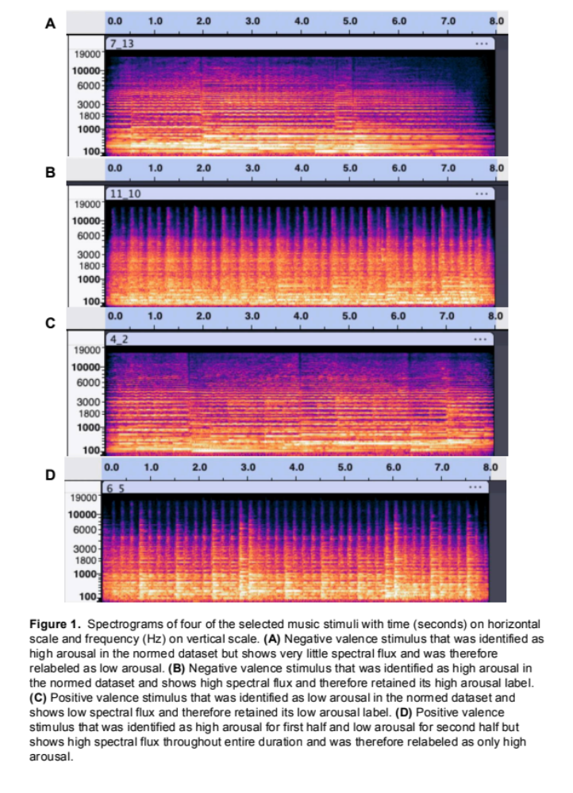
The 10 emotion words used in this task (happy, joyful, excited, satisfied, relaxed, sad, anxious, upset, gloomy, scared) were chosen based on frequently used terms used in previous studies on emotional granularity (Diener et al., 1995; Barrett et al., 2001; Tugade et al., 2004; Kashdan et al., 2010; Erbas et al., 2018; Kalokerinos et al., 2019; Nook et al., 2021a; Vedernikova et al., 2021), along with emotions elicited by music (Eerola & Saari, 2025; Hevner, 1936). Pilot data (n = 61) indicated that, across all the emotion words selected, there was no difference between the magnitude of emotion elicited by music versus pictures with the selected stimuli (i.e., emotional words selected were not biased to be experienced more in response to either music or pictures). The stimuli used in this pilot were the same as the ones used in the present study.

Procedure
Participants completed the study on Gorilla, an online behavioral research platform, and Qualtrics, an online survey platform. Informed consent was obtained in accordance with the IRB-approved protocol 31-8-23 at Northeastern University. After consenting on Gorilla, online participants completed a headphone check (Woods et al., 2017) to ensure that they could hear the musical stimuli properly. Participants were then given instructions on how to complete the emotion rating task. They were told that each picture or music clip would appear for eight seconds and that they should look at the image for all eight seconds or listen to the entirety of the music clip and then rate the ten emotions shown on the screen afterwards based on how much they experienced that emotion while looking or listening. They were then presented with two practice stimuli: one OASIS picture stimulus (not included in the actual set of stimuli) followed by an emotion word response rating screen, and one music stimulus (not the same as any of the actual music stimuli but from the same compositions in Sachs et al. (2023)) followed by an emotion response rating screen. After confirming that the practice was completed, they were then presented with 16 affective musical excerpts (eight negatively- and eight positively-valenced) and 16 OASIS images (eight negatively- and eight positively-valenced) for eight seconds each. A schematic of the emotion rating task is shown in Figure 2.
Presentation of these stimuli was randomized across stimulus type (i.e., visual and musical stimuli were presented randomly in the same block together). After the presentation of each stimulus, participants rated the degree to which they felt five positively-valenced emotions (happy, satisfied, excited, joyful, relaxed) and five negatively-valenced emotions (gloomy, upset, scared, sad, anxious) on a 0-100 scale, with 0 meaning “no experience of that emotion at all” and 100 meaning “maximum experience of that emotion.” This randomized presentation continued until the end of the 32 stimuli, at which point participants were redirected to Qualtrics, where they completed a series of self-report questionnaires, including the Connor-Davidson Resilience Scale (CD-RISC; Connor & Davidson, 2003), Beck Depression Inventory-II (BDI-II; Beck et al., 1996), and State-Trait Anxiety Inventory for Adults (STAI; Spielberger, 1983), as well as basic demographic questions.
At the end of the questionnaires, they were redirected to the third part of the task: the adaptive Musical Emotion Discrimination Test (aMEDT; MacGregor et al., 2023). This task involves listening to 18 pairs of short musical stimuli, where for each pair of stimuli, participants were asked to choose which stimulus expresses a certain emotion more (happy, angry, tender, sad, fearful). The aMEDT is adaptive in that a correct answer leads to the presentation of a pair of stimuli that are more difficult to discriminate between compared to the previous pair.
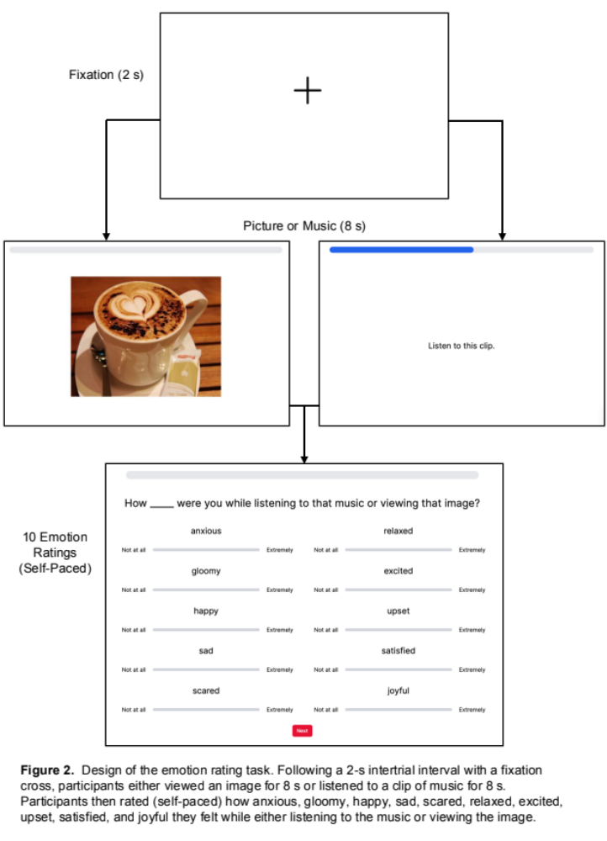
Incorrect answers lead to the presentation of an easier pair of stimuli to discriminate between. Emotion discrimination is measured based on a computationally derived measure that considers both the number of correct answers on the test along with the difficulty of the items themselves. This measure ranges between –2.5 and 2.5, with more positive values representing a greater ability to discriminate between emotions in music.

Analysis Plan
Using the 0-100 scale emotion ratings, we calculated the intraclass correlation coefficient (ICC) of experienced emotion ratings as a measure of experienced emotional granularity in response to either music or visual stimuli (Barrett et al., 2001; Erbas et al., 2019; Nook et al., 2021a). ICC scores were separated by ratings of positively- and negatively-valenced emotion words, for a total of four ICCs per individual. ICCs were calculated using the irr package in R. Specifically, ICC(3,k) was calculated using the icc function, where ICC(3,k) is a two-way mixed effects model for consistency based on the average values of each emotion category at a 95% confidence level (Shrout & Fleiss, 1979). Use of ICC(3,k) is consistent with previous research (Nook et al., 2021a; Kalokerinos et al., 2019). Although negative ICCs are technically impossible, they are not unheard of in the context of emotional granularity. In some contexts, negative ICCs are removed. However, for us, given that negative ICCs would represent maximum granularity (extreme lack of correlation between an individual’s emotions), ICCs with negative values were recoded as 0, which is consistent with prior emotional granularity studies (Hoemann et al., 2023). Since correlations are not usually normally distributed, ICCs were then Fisher r-to-z transformed, in accordance with previous research on emotional granularity (Barrett et al., 2001; Erbas et al., 2019). To make the granularity score more intuitive, scores were then multiplied by –1 such that higher values represented greater levels of emotion differentiation, with 0 representing maximum granularity (Erbas et al., 2019). Combined granularity scores were calculated from the average of an individual’s positive and negative granularity, separated by stimulus type (i.e., music or images). This gave us a total of six granularity scores for each participant.
For our first hypothesis that there would be a positive correlation between emotional granularity scores in response to music and pictures, Pearson’s product moment correlation coefficients were calculated for: positive granularity (music) and positive granularity (pictures), negative granularity (music) and negative granularity (pictures), and combined granularity (music) and combined granularity (pictures).
For our second hypothesis that the magnitude of granularity scores in response to music would be greater in magnitude than scores in response to pictures (in the same pairs as above), we conducted paired samples t-tests at a 95% confidence level.
To determine if there’s a positive correlation between the ability to discriminate emotions in music (aMEDT score) and granularity in response to music, Pearson’s product moment correlation coefficients were calculated for both positive and negative emotional granularity in response to music and aMEDT. Twelve participants were excluded from this analysis due to missing data on the aMEDT.
Finally, associations between granularity and mental health survey measures were also tested this way. Specifically, correlational tests were conducted between positive granularity (music) and resilience (CD-RISC score) and positive granularity (picture) and resilience, negative granularity (music) and depression (BDI-II score) and negative granularity (picture) and depression, and negative granularity (music) and anxiety (STAI score) and negative granularity (picture) and anxiety. Eight participants were excluded from these analyses due to missing survey data.

RESULTS
Positive emotional granularity scores in response to music were found to significantly positively correlated with positive granularity scores in response to pictures, (r(70) = .58, p < .001; Figure 3A). Negative emotional granularity scores were similarly positively correlated, (r(70) = 0.51, p < .001; Figure 3B), as was combined granularity, (r(70) = 0.66, p < .001; Figure 3C). Emotional granularity in response to music was greater for music compared to pictures for positive (music: M = –1.13, SD = 0.43, picture: M = –1.72, SD = 0.53, t(71) = 11.16 and p < .001), negative (music: M = –0.78, SD = 0.44, picture: M = –1.34, SD = 0.50, t(71) = 10.28 and p < .001), and combined (music: M = –0.95, SD = 0.38, picture: M = –1.53, SD = 0.46, t(71) = 13.80 and p < .001) granularity scores (Figure 4).
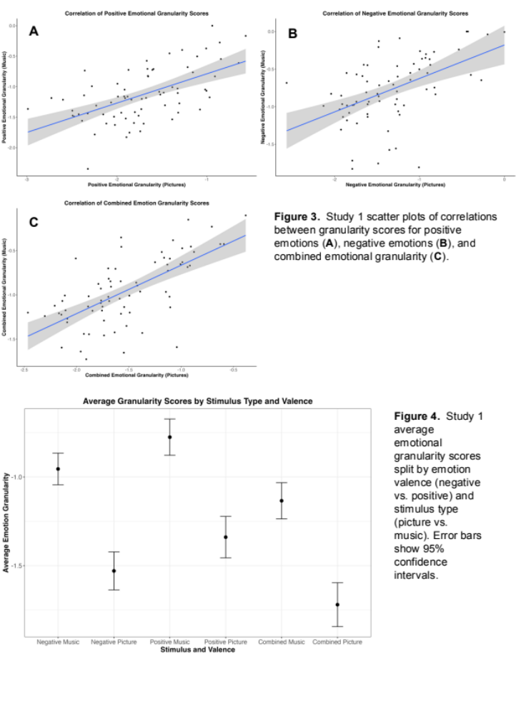
There was a significant positive correlation between negative emotion granularity in response to music and musical emotion discrimination ability scores, (r(58) = .33 and p = .014; Figure 5A), and combined emotional granularity with aMEDT scores, (r(58) = .31 and p = .019; Figure 5B). However, there was no correlation between positive emotion granularity in response to music and musical emotion discrimination ability, (r(58) = .21, p = .12).
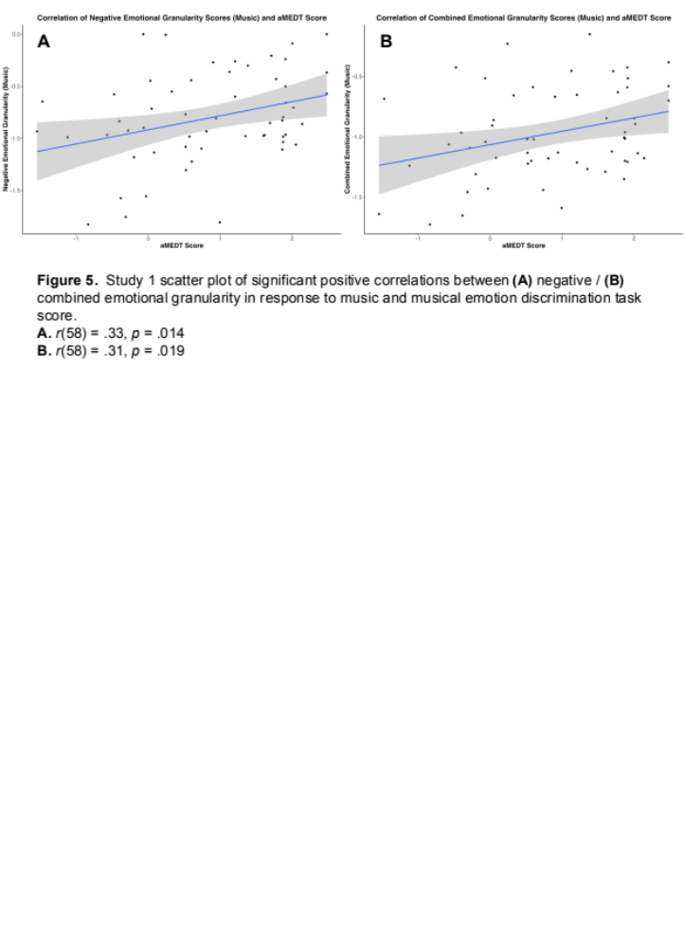
No significant associations were found between positive emotional granularity scores and resilience (CD-RISC), or negative emotional granularity scores and depression (BDI-II) or anxiety (STAI) (Table 2).
Table 2 Correlations with Mental Health Measures
Mental Health Measure: |  | CD-RISC-10 | BDI-II | STAI
Granularity | Stimulus Type | n = 64 | n = 64 | n = 64
Positive | Music | .09
Positive | Picture | .09
Negative | Music |  | 0 | –.08
Negative | Picture |  | –.15 | –.21
Bivariate correlations relating Connor-Davidson Resilience Scale (CD-RISC-10), Beck Depression Inventory-II (BDI-II) and State-Trait Anxiety Inventory (STAI) to measures of emotional granularity from the Study 1 sample. * p < .05, ** p <.01, *** p <.001

STUDY 2

INTRODUCTION
The neurological basis of emotional processing in both speech and music has been widely studied, with compelling evidence pointing to overlapping neural mechanisms. Listening to music activates emotion and reward-related brain circuits, including the mesolimbic dopaminergic system, a key pathway for reward and motivation, with implicated structures including the ventral and dorsal striatum, anterior cingulate cortex, orbitofrontal cortex, and secondary somatosensory cortex (Mas-Herrero et al., 2021; Salimpoor et al., 2011, 2013; Belden et al., 2023; Koelsch, 2014, 2020). The medial temporal lobe, including the amygdala and anterior hippocampus, as well as the ventromedial prefrontal cortex are also involved in evaluating emotional responses to music, reinforcing their roles in affective processing and controlling emotional responses (Blood & Zatorre, 2001; Dellacherie et al., 2008; Khalfa et al., 2008). The amygdala in particular plays an important role in the recognition of danger and fear in music, just as it does in non-musical contexts, as determined by patients with amygdala resections showing impaired recognition of fear-inducing music (Gosselin et al., 2005).
Further studies highlight the integration of sensory and affective cues in music and emotion perception. Baumgartner et al. (2006) demonstrated that emotional responses to visual stimuli were significantly enhanced when paired with music, suggesting that musical stimuli amplify the perception and experience of emotion. These findings align with research on emotional speech perception, in which prosodic cues—such as frequency, amplitude, and timing—engage a frontotemporal network, including the bilateral auditory cortices, superior temporal cortex, and inferior frontal gyrus (IFG) (Schirmer & Kotz, 2006; Dricu & Frühholz, 2016; Frühholz & Grandjean, 2013a, 2013b; Frühholz et al., 2016).

The Inferior Frontal Cortex
The inferior frontal cortex (IFC), including both the pars triangularis (BA45) and pars orbitalis (BA47), plays a critical role in processing emotional cues in both speech and music. In children, greater IFG connectivity with motor regions (primary motor, lateral premotor, and supplementary motor areas) has been linked to stronger emotional speech perception skills, emphasizing the role of the pars triangularis in integrating auditory and motor aspects of communication (Correia et al., 2019). Together, pars opercularis (BA44) and pars triangularis (BA45) constitute Broca’s area, which is primarily responsible for language production and comprehension (Flinker et al., 2015). Studies on prosody perception indicate that the right IFC, particularly pars opercularis (BA44) and pars triangularis (BA45) may be specialized for decoding and evaluating emotional vocalizations (Buchanan et al., 2000; George et al., 1996; Wildgruber et al., 2005). In contrast, the left IFC (including BA44 and BA45) is more involved in syntactic and semantic processing (Friederici, 2012). However, some studies suggest bilateral IFC involvement in emotional prosody processing (Beaucousin et al., 2007; Frühholz et al., 2012; Kotz et al., 2003; Morris et al., 1999), while others have even found left IFC-specific activity in vocal emotion processing (Wildgruber et al., 2002; Adolphs et al., 2002; Roher et al., 2012).
Beyond the IFG, other frontotemporal and limbic regions contribute to emotional prosody processing. The bilateral fronto-opercular region is activated by prosodic speech containing emotional cues (Kotz et al., 2003). The anterior insula, a structure implicated in interoceptive awareness, also exhibits heightened responses to emotional vocalizations, underscoring its involvement in affective prosody processing (Morris et al., 1999). Additionally, emotional prosody has been linked to distinct right hemisphere activations in the posterior superior temporal sulcus (BA22), dorsolateral prefrontal cortex (BA44/45), and orbitobasal frontal areas (BA47) (Wildgruber et al., 2005). While BA47 is in close proximity to the pars orbitalis, they are not entirely synonymous, though both are implicated in evaluating and integrating emotional information in speech and music.

Emotional Granularity and Neuroanatomical Correlates
Differences in emotional granularity are associated with differences in neural processing of emotional experiences, with high granularity potentially being associated with stronger executive control of resources for consistent processing of affective stimuli (Lee et al., 2017). Individuals with degeneration of the frontal and temporal lobes show activity in more brain regions involved in the resting-state functional connectivity associated with emotional processing, suggesting that this lack of control of resources for emotion processing is related to a loss of functional specificity within emotional processing networks (Canu et al., 2022).
Individual differences in emotional granularity—the ability to distinguish between nuanced emotional states—have recently been linked to IFC cortical thickness. Greater cortical thickness in the right and left lateral orbitofrontal cortex, with extension into the dorsal anterior insula, has been associated with higher emotional granularity in older adults (Lukic et al., 2023). Given the IFC’s role in cognitive control, behavioral inhibition, and emotion regulation (Aron et al., 2014; Dörfel et al., 2014; Li et al., 2021; Ochsner et al., 2004; Phan et al., 2005; Picó-Pérez et al., 2019), this structural relationship suggests that greater IFC integrity may support more nuanced emotional processing. Moreover, emotion labeling and meaning-making—both of which engage the IFC, particularly BA45/47—play a crucial role in deriving meaning from musical and verbal emotional cues (Brooks et al., 2017; Goldin et al., 2008; Hariri et al., 2000; Lieberman et al., 2005, 2007; Phan et al., 2005; Torre & Lieberman, 2018).
Music provides a unique and ecologically valid model for studying emotion in the brain, offering a controlled yet naturalistic means of eliciting affective responses. Unlike language, which conveys explicit semantic meaning, instrumental music can express emotion through structural and auditory features alone, making it an ideal tool for investigating neural responses to emotional stimuli without lexical confounds. The same neural circuits involved in emotional prosody and vocal affect—such as the IFG (BA44/45/47), superior temporal cortex (BA22), anterior insula, and orbitofrontal cortex—are also recruited during musical emotion perception (Wildgruber et al., 2005; Kotz et al., 2003; Morris et al., 1999). Given correlations that have been found being emotional granularity and emotion perception (i.e., recognizing the emotions expressed by facial expressions of other people) (Israelashvili et al., 2019; Erbas et al., 2016), there may be similar correlations between musical emotional granularity and musical emotion perception.
Some distinctions have been found between the specific affective state induced by music and the regions of the brain activated during that affective experience. Listening to positively-valenced classical music shows activity in BA44, BA45, the ventral and dorsal striatum (involved in reward experience and movement), anterior cingulate and anterior superior insula, and parahippocampal gyrus, while negatively-valenced music activates the hippocampus, amygdala, and parahippocampal gyrus, which are all implicated in the appraisal and processing of emotions (Koelsch et al., 2006; Mitterschiffthaler et al., 2007). Even listening to unfamiliar instrumental music passively shows activation in the subcallosal cingulate gyrus, prefrontal anterior cingulate, hippocampus, anterior insula, and nucleus accumbens (Brown et al., 2004).
Furthermore, the interplay between motor and auditory regions in music perception mirrors the mechanisms underlying speech prosody processing. The motor system, particularly the IFG, premotor cortex, and supplementary motor area, is engaged not only in vocal production but also in emotional speech and music perception, reinforcing the sensorimotor integration hypothesis—the idea that our ability to perceive and interpret emotional sounds is shaped by the same neural mechanisms involved in producing them (Correia et al., 2019; Patel & Iversen, 2014).
By examining how music evokes emotions and engages reward, limbic, and cognitive control networks, researchers can gain deeper insights into the fundamental neural mechanisms underlying human emotional experience. As research continues to bridge the gap between music, speech, and emotional processing, music may be a powerful tool for exploring how the brain encodes, interprets, and regulates emotion.

Current Study
In the current study we aimed to replicate hypotheses 1 and 2 from Study 1. We additionally hypothesized that we would replicate the positive correlation between emotional granularity and cortical thickness of the inferior frontal cortex cortical thickness (Lukic et al., 2023), using the same granularity task and musical emotion discrimination task as the first study but with the addition of structural magnetic resonance imaging.

MATERIALS AND METHODS

Data Collection

Participants
Study 2 consisted of 50 participants who all completed the study in-person at Northeastern University’s Interdisciplinary Science and Engineering Complex as part of a broader experimental protocol. Participants were recruited from the Greater Boston area. Demographic data for the sample are shown in Table 2. All participants gave written informed consent and completed an MRI pre-screening phone call and pre-entry screening form.
Table 3 Study 2 Sample Demographics
Demographic | Study 2 sample  (n = 50)
Age
Mean (SD) | 21 (1.32)
Range | 18–24 years
Sex
Male | 22 (44%)
Female | 28 (56%)
Gender
Man | 22 (44%)
Woman | 27 (54%)
Non-binary | 1 (2%)
Race/Ethnicity
American Indian or Alaska Native | 0 (0%)
Asian | 15 (30%)
Black or African American | 2 (4%)
Hispanic or Latino | 0 (0%)
Native Hawaiian or Other Pacific Islander | 0 (0%)
White | 21 (42%)
Two or more races | 12 (24%)
Demographic information for the Study 2 sample

Materials
The same emotion rating task and aMEDT from Study 1 were administered in Study 2.

Procedure
Participants completed the study in two separate sessions on separate days. The aMEDT was one of the tasks completed on the first day, and the emotion rating task and MRI were part of the second day. In the MRI, patients remained awake and watching short films while structural scans were completed.
4 of the participants were individuals that were sent the emotion rating task and aMEDT as optional follow-up tasks after having previously participated in a study at the MIND Lab prior to the start of data collection for this study. Those 4 completed the tasks online, while the other 46 completed the tasks in the MIND Lab space in-person.
MRI Data Acquisition
Neuroimaging was acquired using a Siemens Magnetom 3 T MR scanner with a 64-channel head coil at Northeastern University. T1 images were acquired using a magnetization prepared rapid gradient echo sequence, with one T1 image acquired every 2400 msec, for a total task time of approximately 7 min. Sagittal slices (0.8 mm thick, anterior to posterior) were acquired covering the whole brain (TR = 9.9 msec, echo time = 4.6 msec, flip angle = 2°, field of view = 256, voxel size = 0.8 × 0.8 × 0.8 mm3). Anatomical images were obtained using a T1-weighted image.

Analysis Plan

MRI Preprocessing
Results included in this manuscript come from preprocessing performed using fMRIPrep 24.0.0 (Esteban et al. (2019); Esteban et al. (2018); RRID:SCR_016216), which is based on Nipype 1.8.6 (K. Gorgolewski et al. (2011); K. J. Gorgolewski et al. (2018); RRID:SCR_002502).
The T1-weighted (T1w) image was corrected for intensity non-uniformity (INU) with N4BiasFieldCorrection (Tustison et al., 2010), distributed with ANTs 2.5.1 (Avants et al., 2008, RRID:SCR_004757), and used as T1w-reference throughout the workflow. The T1w-reference was then skull-stripped with a Nipype implementation of the antsBrainExtraction.sh workflow (from ANTs), using OASIS30ANTs as target template. Brain tissue segmentation of cerebrospinal fluid (CSF), white-matter (WM) and gray-matter (GM) was performed on the brain-extracted T1w using fast (FSL (version unknown), RRID:SCR_002823, Zhang, Brady, and Smith, 2001). An anatomical T2w-reference map was computed after registration of 3 T2w images (after INU-correction) using mri_robust_template (FreeSurfer 7.3.2, Reuter, Rosas, and Fischl, 2010). Brain surfaces were reconstructed using recon-all (FreeSurfer 7.3.2, RRID:SCR_001847, Dale, Fischl, and Sereno, 1999), and the brain mask estimated previously was refined with a custom variation of the method to reconcile ANTs-derived and FreeSurfer-derived segmentations of the cortical gray-matter of Mindboggle (RRID:SCR_002438, Klein et al., 2017). Volume-based spatial normalization to one standard space (MNI152NLin2009cAsym) was performed through nonlinear registration with antsRegistration (ANTs 2.5.1), using brain-extracted versions of both T1w reference and the T1w template. The following template was selected for spatial normalization and accessed with TemplateFlow (24.2.0, Ciric et al., 2022): ICBM 152 Nonlinear Asymmetrical template version 2009c [Fonov et al. (2009), RRID:SCR_008796; TemplateFlow ID: MNI152NLin2009cAsym].

ROI Cortical Thickness Analysis
Anatomical data preprocessing was done through FreeSurfer using a T1-weighted image and recon-all for cortical surface reconstruction. This returned measures of cortical thickness and subcortical volume measures. The Destrieux atlas (aparc.a2009s) was used to isolate the inferior frontal cortex ROIs, given that the Destrieux atlas is parcellated into 148 ROIs (Figure 6), while the Desikan-Killiany atlas (default for FreeSurfer aparc_stats) is parcellated into 68 ROIs. Specific ROIs in the inferior frontal cortex were selected based on those analyzed in Lukic et al. (2023): the posterior inferior frontal gyrus, comprising of pars opercularis (BA44) and pars triangularis (BA45), the lateral orbitofrontal cortex, comprising of pars orbitalis (BA47), BA12, and BA11, and the dorsal anterior insula. The Destrieux atlas includes BA44, BA45, and BA47 explicitly and were analyzed as such. The other regions were approximated using the broader orbitofrontal gyrus thickness for BA12, lateral sulcus and H-shaped orbital sulcus for BA12, and the larger gyrus of the insula and superior circular sulcus of the insula for the dorsal anterior insula, for a total of eight ROIs from the atlas (Figure 7). Parcellation statistics of cortical thickness for both hemispheres for these regions were analyzed for Pearson’s correlations with all six granularity scores for participants.

Study 1 Replication
The emotion rating task and aMEDT were analyzed as in Study 1 in order to replicate the results of Study 1 with the additional structural correlations of Study 2. The 4 participants mentioned in Participants completed both tasks online after having already completed their two sessions. Our final sample size for the aMEDT was 48 due to missing data from 2 participants.
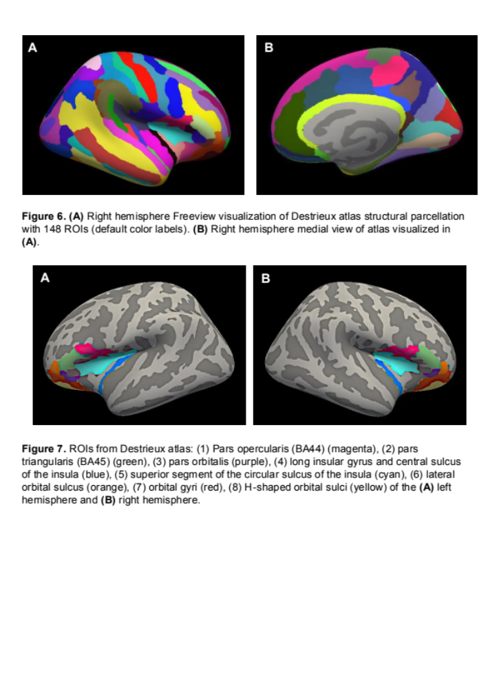

RESULTS
Positive emotional granularity scores in response to music were significantly positively correlated with positive granularity scores in response to pictures, (r(48) = .65, p < .001; Figure 8A). Negative emotional granularity scores were similarly positively correlated, (r(48) = .62, p < .001; Figure 8B), as was combined granularity, (r(48) = .73, p < .001; Figure 8C). Emotional granularity in response to music was greater for music compared to pictures for positive (music: M = –0.99, SD = 0.48, pictures: M = –1.59, SD = 0.55, t(49) = 9.86 and p < .001), negative (music: M = –0.64, SD = 0.40, pictures: M = –1.38, SD = 0.49, t(49) = 13.28 and p < .001), and combined (music: M = –0.81, SD = 0.38, pictures: M = –1.48, SD = 0.47, t(49) = 14.67 and p < .001) granularity scores (Figure 9).
There were no significant correlations between aMEDT scores and positive emotion granularity in response to music, (r(46) = –.07, p = .62), negative emotion granularity in response to music, (r(46) = –.21 and p = .15), or combined emotional granularity in response to music, (r(46) = –.15 and p = .29).
With the eight ROIs we identified, a positive correlation was found between the cortical thickness of the right hemisphere BA45, pars triangularis, and negative emotional granularity in response to music, r(48) = .28 and p = .047 (Figure 10). The right pars triangularis is shown in green in Figure 11. Correlations between granularity scores and all ROIs of both hemispheres are shown in Table 4.

Table 4 Structural Correlations with Granularity
 |  | Granularity
 |  | Positive |  | Negative |  | Combined
Stimulus Type |  | Music | Picture | Music | Picture | Music | Picture
ROI | Hemisphere
Pars opercularis | Right | .19 | .08 | .18 | .03 | .21 | .06
Pars opercularis | Left | –.19 | –.06 | .06 | 0 | –.09 | –.04
Pars triangularis | Right | .10 | .07 | .28* | .07 | .21 | .08
Pars triangularis | Left | .07 | .05 | .05 | .01 | .07 | .04
Pars orbitalis | Right | –.01 | –.21 | –.05 | –.25 | –.03 | –.25
Pars orbitalis | Left | .05 | 0 | .12 | .08 | .10 | .04
Long insular gyrus and central sulcus of the insula | Right | –.09 | –.07 | –.03 | .12 | –.07 | .02
Long insular gyrus and central sulcus of the insula | Left | –.04 | .07 | .07 | .26 | .01 | .18
Superior segment of the circular sulcus of the insula | Right | .07 | .04 | .16 | .06 | .13 | .06
Superior segment of the circular sulcus of the insula | Left | –.15 | –.14 | –.06 | –.11 | –.12 | –.14
Lateral orbital sulcus | Right | –.01 | –.03 | –.09 | 0 | .06 | –.01
Lateral orbital sulcus | Left | .05 | –.02 | .06 | .01 | .06 | 0
Orbital gyri | Right | –.05 | –.14 | –.09 | –.17 | –.08 | –.17
Orbital gyri | Left | –.21 | –.25 | –.20 | –.09 | –.24 | –.19
H-shaped orbital sulci | Right | .17 | .17 | .05 | .08 | .02 | .14
H-shaped orbital sulci | Left | –.09 | –.15 | –.11 | –.17 | –.12 | –.18
Bivariate correlations relating the eight ROIs to measures of emotional granularity from the Study 2 sample. * p < .05, ** p <.01, *** p <.001
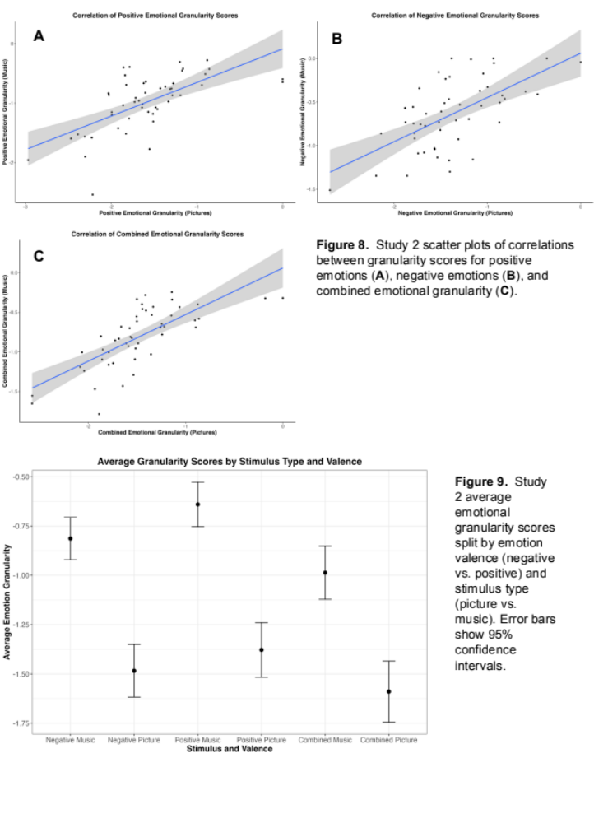
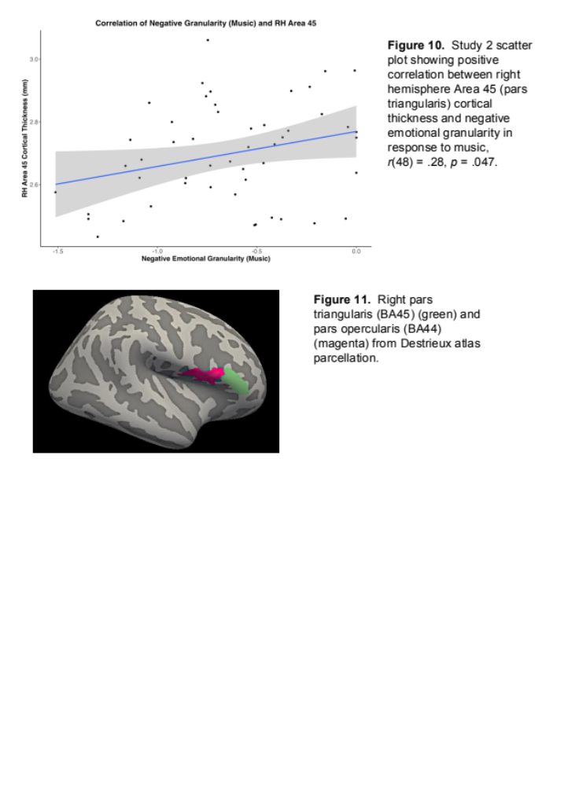

DISCUSSION
In the present study, we examined emotional granularity in response to music and picture stimuli. Consistent with our first hypothesis, we found a significant positive correlation between emotional granularity in response to music and in response to picture stimuli, suggesting that the construct measured via static images is similarly captured through music. Supporting our second hypothesis, emotional granularity was significantly higher for music than for picture stimuli. In Study 1, we observed a significant positive relationship between negative emotional granularity in response to music and musical emotion discrimination ability, partially supporting our third hypothesis; however, this association was not replicated in Study 2, suggesting that emotional differentiation and musical emotion perception may rely on distinct processes. Lastly, contrary to our fourth hypothesis, we did not find significant correlations between positive emotional granularity and resilience or between negative emotional granularity and depressive or anxious symptoms. However, structural MRI data in Study 2 revealed a positive correlation between cortical thickness in the right pars triangularis (BA45) and negative emotional granularity in response to music, partially replicating prior findings linking emotional granularity to inferior frontal cortex cortical thickness (Lukic et al., 2023). These results underscore music’s potential as a more ecologically valid tool for studying emotion differentiation and highlight the need for further research into the neural mechanisms underlying emotional granularity.
Emotional granularity in response to music was significantly positively correlated with emotional granularity in response to picture stimuli. This suggests that the psychological construct measured via images is similar to that using music. Prior research has typically examined emotional granularity using static visual stimuli (e.g., Nook et al., 2018; Erbas at al., 2018), and our findings indicate that music can serve as a valid alternative for assessing this phenomenon.
Emotional granularity was significantly higher for music than for picture stimuli. This finding suggests that music’s temporally unfolding nature allows for more nuanced differentiation of emotional states. This aligns with prior research demonstrating that music provides a richer emotional experience than static stimuli (Baumgartner et al., 2006; Juslin & Laukka, 2003), reinforcing the idea that music’s dynamic and temporally unfolding nature may allow for more nuanced emotional differentiation. The continuous nature of music may provide listeners with additional contextual cues for emotion differentiation, whereas pictures offer only a significant moment in time, which may limit individuals’ abilities to process general affect into specific emotions. The finding of higher granularity for music is also consistent with previously raised concerns regarding the ecological validity of static stimuli in granularity research (Thompson et al., 2021). Using music as a stimulus may be a step toward more ecologically valid assessments of emotional granularity, potentially serving as an alternative to experience sampling methods.
Our hypothesis that musical emotional discrimination ability would correlate with emotional granularity received mixed support. In Study 1, we observed a significant positive correlation between negative emotional granularity in response to music and musical emotion discrimination ability. However, this association was not replicated in Study 2. The inconsistency between the two studies suggests that while emotion perception ability and differentiation share some common mechanisms, they may not be entirely overlapping. This aligns with existing musical emotion research on perceived emotion versus felt emotion, where the emotions perceived in musical pieces do not necessarily coincide with the emotions felt by listeners (Kawakami et al., 2013).
Prior research also suggests that emotion perception in music relies on learned associations between acoustic features and emotional categories (Juslin & Laukka, 2003), whereas emotional granularity involves an individual’s ability to introspectively differentiate their own emotional experiences (Barrett et al., 2001). For example, in the stimuli presented in the aMEDT, excerpts intended to be “angry” were generally at a louder dynamic with accented articulations (sometimes marcato, sometimes staccato) and bright overtones, whereas “happy” excerpts were at a loud dynamic with more legato phrasing and less harsh overtones. It is entirely possible to learn these characteristics through methods that don’t require a connection to one’s own emotional states, such as through formal musical training. This discrepancy aligns with findings that the ability to differentiate one’s own emotional experiences is not necessarily correlated with the ability to accurately perceive and identify emotions depicted by others in external scenarios (Gregory et al., 2020). Future studies should further investigate whether these abilities rely on different cognitive or neural resources.
We did not find significant correlations between emotional granularity and measures of resilience, depression, or anxiety. This stands in contrast to prior research showing that higher positive emotional granularity is associated with resilience (Tugade et al., 2004) and that higher negative emotional granularity negatively correlated with depression (Willroth et al., 2020) and anxiety (Seah et al., 2020; Erbas et al., 2014). One issue lies in how individuals make use of emotion labels for their emotional experiences. Research has indeed shown that a significantly lower ability to identify and describe one’s emotions, known as alexithymia (Sifneos, 2010), is associated with challenges with cognitive reappraisal of emotional experiences (Swart et al., 2009), worse mental health symptoms (Leweke et al., 2011; Taylor et al., 1997), and poorer therapeutic outcomes (Ogrodniczuk et al., 2011). However, research has also found that assigning a specific label to an emotional experience may “crystallize” one’s affective experience and make it more difficult to reappraise the situation (Nook et al., 2021b). Therefore, while some individuals may use emotion labels as a means for identifying specific emotion regulation mechanisms, others may experience emotion labels as impeding emotion regulation rather than facilitating it. Other studies find that affect labeling acts as a form of implicit emotion regulation where labeling may not necessarily feel like an active regulatory process, but still has significant effects (Torre & Lieberman, 2018). These discrepancies suggest that there is a need for not only measuring individuals’ own differentiation abilities but also providing them with the emotion regulation tools to use those abilities to their advantage. This highlights the importance of specific targeted therapeutic interventions in facilitating practical uses of emotion differentiation.
However, it is worth noting the difference in methodologies between the present study and those used in Seah et al. (2020), Erbas et al. (2014), and Willroth et al. (2020)—all of which measured emotional granularity through experience sampling. Given the difficulties with ecological validity when measuring emotional granularity with standardized stimulus response tasks as opposed to experience sampling, it is possible that the correlations with mental health measures found in these previous studies reflect methodological differences. The challenge of maintaining high ecological validity with standardized stimulus response tasks may not be one that will be overcome simply by changing the types of stimuli used. However, that isn’t to say that these tasks cannot be improved to be at least somewhat more representative of daily experiences of emotions. Given music’s ability to unfold over time and bring listeners through different affective states, as well as our findings in this study, music may be an effective step forward with improving the methodologies for studying the complexities of emotional granularity.
The positive correlation between cortical thickness in the right pars triangularis (BA45) and negative emotional granularity in response to music, partially replicating previous findings linking emotional granularity to inferior frontal cortex cortical thickness (Lukic et al., 2023). The inferior frontal cortex has been implicated in the controlled retrieval of semantic knowledge (Lau et al., 2008) and plays a critical role in emotion labeling and regulation (Brooks et al., 2017; Lieberman et al., 2005, 2007). The left inferior frontal gyrus specifically is involved in the selection of semantic knowledge (Thompson-Schill et al., 1997). The right pars triangularis, in particular, has been associated with higher-order language and semantic processing (Levy & Wagner, 2011), which may explain its relationship with emotional granularity.
The role of the right versus left pars triangularis has been disputed, given that some studies on prosody perception indicate that the right BA44 and BA45 may be specialized for decoding and evaluating emotional vocalizations (Buchanan et al., 2000; George et al., 1996; Wildgruber et al., 2005), with the left BA44 and BA45 being more involved in syntactic and semantic processing (Friederici, 2012), while others have found bilateral IFC involvement in emotional prosody processing (Beaucousin et al., 2007; Frühholz et al., 2012; Kotz et al., 2003; Morris et al., 1999). Future studies should analyze the activity levels of both the right and left pars triangularis while listening to music and completing an emotional granularity task to determine whether this lateralization of function is indeed the case. In either case, the right pars triangularis still plays a role in selection and retrieval of affective labels and given that emotional differentiation relies on an individual’s ability to precisely label their emotional states (Barrett et al., 2001), these findings support the notion that individual differences in emotional granularity may be tied to structural differences in the inferior frontal cortex.
Our results did not show survive correction for multiple comparisons, and correlations with other inferior frontal cortex regions were not significant. However, Lukic et al. (2023) collected data over the course of 8 weeks with participants completing daily experience surveys, a form of experience sampling that is known to be more ecologically valid than stimulus response tasks. The higher ecological validity of this kind of emotional granularity study may explain part of the discrepancy (i.e., our lack of correlations for other IFC regions). Additionally, given that Lukic et al. (2023) used a different atlas for parcellation there may have been methodological issues with the Destrieux parcellation we used that made it more difficult to find significant correlations with the left pars triangularis and potentially other IFC regions. For example, the distinction between pars triangularis and pars opercularis is not always clear (as can be seen by the proximity of pars triangularis to pars opercularis in Figure 11).
Our findings contribute to the growing literature on emotional granularity by demonstrating that music can be an effective tool for assessing emotion differentiation. The higher granularity observed for music suggests that musical stimuli may offer a more ecologically valid alternative to static images, potentially addressing limitations of previous research that relied solely on picture-based tasks. Additionally, our results highlight the need for further investigation into the relationship between emotion differentiation and neural structures, particularly in the inferior frontal cortex.
Future research should explore whether music-based granularity assessments provide stronger predictions for real-world emotional regulation and mental health outcomes than traditional static stimuli. One way to do so would be to conduct both an experience sampling and stimulus response study with the same sample of participants, as in Erbas et al. (2019), to find the correlation between granularity as measured by experience sampling versus granularity measured through a stimulus response task and determine if there is a stronger correlation between experience sampling-based granularity and granularity with music stimuli or picture stimuli. Doing so will help to clarify the ecological validity of granularity as measured with music, potentially allowing us to further understand the relationship between granularity and mental health. Furthermore, future studies should explore the correlation between not only musical emotional granularity and internal emotion regulation, but also granularity and external emotion regulation methods (i.e., helping others with the intention of regulating one’s own negative emotions). Given that granularity and external regulation methods have been studied in non-Western contexts (Jeong et al., 2022), this would provide insight into the cross-cultural validity of music as a means of measuring emotional granularity.
This study expands our understanding of emotional granularity by demonstrating its consistency across different stimulus modalities and highlighting the advantages of music as an assessment tool. While our findings provide important insights into the neural correlates of emotional granularity, they also underscore the need for further research into the ecological validity of different measurement approaches. As affective science continues to evolve, integrating music into granularity research may offer new avenues for understanding the complexities of emotion differentiation and its role in emotion regulation.

REFERENCES
Adolphs, R., Damasio, H., & Tranel, D. (2002). Neural systems for recognition of emotional prosody: A 3-D lesion study. Emotion, 2(1), 23–51. https://doi.org/10.1037/1528-3542.2.1.23
Altenmüller, E., Schürmann, K., Lim, V. K., & Parlitz, D. (2002). Hits to the left, flops to the right: Different emotions during listening to music are reflected in cortical lateralisation patterns. Neuropsychologia, 40(13), 2242–2256. https://doi.org/10.1016/S0028-3932(02)00107-0
Aron, A. R., Robbins, T. W., & Poldrack, R. A. (2004). Inhibition and the right inferior frontal cortex. Trends in Cognitive Sciences, 8(4), 170–177. https://doi.org/10.1016/j.tics.2004.02.010
Aron, A. R., Robbins, T. W., & Poldrack, R. A. (2014). Right inferior frontal cortex: Addressing the rebuttals. Frontiers in Human Neuroscience, 8. https://doi.org/10.3389/fnhum.2014.00905
Avants, B. B., C. L. Epstein, M. Grossman, and J. C. Gee. 2008. “Symmetric Diffeomorphic Image Registration with Cross-Correlation: Evaluating Automated Labeling of Elderly and Neurodegenerative Brain.” Medical Image Analysis 12 (1): 26–41. https://doi.org/10.1016/j.media.2007.06.004.
Bachorik, J. P., Bangert, M., Loui, P., Larke, K., Berger, J., Rowe, R., & Schlaug, G. (2009). Emotion in Motion: Investigating the Time-Course of Emotional Judgments of Musical Stimuli. Music Perception, 26(4), 355–364. https://doi.org/10.1525/mp.2009.26.4.355
Barrett, L. F. (2006). Solving the Emotion Paradox: Categorization and the Experience of Emotion. Personality and Social Psychology Review, 10(1), 20–46. https://doi.org/10.1207/s15327957pspr1001_2
Barrett, L. F. (2017). The theory of constructed emotion: An active inference account of interoception and categorization. Social Cognitive and Affective Neuroscience, 12(1), 1–23. https://doi.org/10.1093/scan/nsw154
Barrett, L. F., Gross, J., Christensen, T. C., & Benvenuto, M. (2001). Knowing what you’re feeling and knowing what to do about it: Mapping the relation between emotion differentiation and emotion regulation. Cognition and Emotion, 15(6), 713–724. https://doi.org/10.1080/02699930143000239
Baumgartner, T., Esslen, M., & Jäncke, L. (2006). From emotion perception to emotion experience: Emotions evoked by pictures and classical music. International Journal of Psychophysiology, 60(1), 34–43. https://doi.org/10.1016/j.ijpsycho.2005.04.007
Beaucousin, V., Lacheret, A., Turbelin, M.-R., Morel, M., Mazoyer, B., & Tzourio-Mazoyer, N. (2007). FMRI study of emotional speech comprehension. Cerebral Cortex (New York, N.Y.: 1991), 17(2), 339–352. https://doi.org/10.1093/cercor/bhj151
Beck, A. T., Steer, R. A., & Brown, G. (1996). Beck Depression Inventory–II [Dataset]. https://doi.org/10.1037/t00742-000
Block, J., & Kremen, A. M. (1996). IQ and ego-resiliency: Conceptual and empirical connections and separateness. Journal of Personality and Social Psychology, 70(2), 349–361. https://doi.org/10.1037/0022-3514.70.2.349
Blood, A. J., & Zatorre, R. J. (2001). Intensely pleasurable responses to music correlate with activity in brain regions implicated in reward and emotion. Proceedings of the National Academy of Sciences, 98(20), 11818–11823. https://doi.org/10.1073/pnas.191355898
Brattico, E., & Jacobsen, T. (2009). Subjective Appraisal of Music. Annals of the New York Academy of Sciences, 1169(1), 308–317. https://doi.org/10.1111/j.1749-6632.2009.04843.x
Brooks, J. A., Shablack, H., Gendron, M., Satpute, A. B., Parrish, M. H., & Lindquist, K. A. (2017). The role of language in the experience and perception of emotion: A neuroimaging meta-analysis. Social Cognitive and Affective Neuroscience, 12(2), 169–183. https://doi.org/10.1093/scan/nsw121
Brown, S., Martinez, M. J., & Parsons, L. M. (2004). Passive music listening spontaneously engages limbic and paralimbic systems. NeuroReport, 15(13), 2033–2037.
Buchanan, T. W., Lutz, K., Mirzazade, S., Specht, K., Shah, N. J., Zilles, K., & Jäncke, L. (2000). Recognition of emotional prosody and verbal components of spoken language: An fMRI study. Cognitive Brain Research, 9(3), 227–238. https://doi.org/10.1016/S0926-6410(99)00060-9
Canu, E., Calderaro, D., Castelnovo, V., Basaia, S., Magno, M. A., Riva, N., Magnani, G., Caso, F., Caroppo, P., Prioni, S., Villa, C., Pain, D., Mora, G., Tremolizzo, L., Appollonio, I., Poletti, B., Silani, V., Filippi, M., & Agosta, F. (2022). Resting state functional brain networks associated with emotion processing in frontotemporal lobar degeneration. Molecular Psychiatry, 27(11), 4809–4821. https://doi.org/10.1038/s41380-022-01612-9
Ciric, R., William H. Thompson, R. Lorenz, M. Goncalves, E. MacNicol, C. J. Markiewicz, Y. O. Halchenko, et al. 2022. “TemplateFlow: FAIR-Sharing of Multi-Scale, Multi-Species Brain Models.” Nature Methods 19: 1568–71. https://doi.org/10.1038/s41592-022-01681-2.
Coan, J. A., & Allen, J. J. B. (2007). Handbook of Emotion Elicitation and Assessment. Oxford University Press, USA.
Connor, K. M., & Davidson, J. R. T. (2003). Development of a new resilience scale: The Connor-Davidson Resilience Scale (CD-RISC). Depression and Anxiety, 18(2), 76–82. https://doi.org/10.1002/da.10113
Correia, A. I., Branco, P., Martins, M., Reis, A. M., Martins, N., Castro, S. L., & Lima, C. F. (2019). Resting-state connectivity reveals a role for sensorimotor systems in vocal emotional processing in children. NeuroImage, 201, 116052. https://doi.org/10.1016/j.neuroimage.2019.116052
Dale, Anders M., Bruce Fischl, and Martin I. Sereno. 1999. “Cortical Surface-Based Analysis: I. Segmentation and Surface Reconstruction.” NeuroImage 9 (2): 179–94. https://doi.org/10.1006/nimg.1998.0395.
Dean, R. T., Bailes, F., & Schubert, E. (2011). Acoustic Intensity Causes Perceived Changes in Arousal Levels in Music: An Experimental Investigation. PLOS ONE, 6(4), e18591. https://doi.org/10.1371/journal.pone.0018591
Dellacherie, D., Ehrlé, N., & Samson, S. (2008). Is the neutral condition relevant to study musical emotion in patients? Music Perception, 25(4), 285–294. https://doi.org/10.1525/mp.2008.25.4.285
DeNora, T. (1999). Music as a technology of the self. Poetics, 27(1), 31–56. https://doi.org/10.1016/S0304-422X(99)00017-0
Destrieux, C., Fischl, B., Dale, A., & Halgren, E. (2010). Automatic parcellation of human cortical gyri and sulci using standard anatomical nomenclature. NeuroImage, 53(1), 1–15. https://doi.org/10.1016/j.neuroimage.2010.06.010
Dörfel, D., Lamke, J.-P., Hummel, F., Wagner, U., Erk, S., & Walter, H. (2014). Common and differential neural networks of emotion regulation by Detachment, Reinterpretation, Distraction, and Expressive Suppression: A comparative fMRI investigation. NeuroImage, 101, 298–309. https://doi.org/10.1016/j.neuroimage.2014.06.051
Dricu, M., & Frühholz, S. (2016). Perceiving emotional expressions in others: Activation likelihood estimation meta-analyses of explicit evaluation, passive perception and incidental perception of emotions. Neuroscience & Biobehavioral Reviews, 71, 810–828. https://doi.org/10.1016/j.neubiorev.2016.10.020
Dubé, L., & Le Bel, J. (2003). The content and structure of laypeople’s concept of pleasure. Cognition and Emotion, 17(2), 263–295. https://doi.org/10.1080/02699930302295
Eerola, T., & Saari, P. (2025). What emotions does music express? Structure of affect terms in music using iterative crowdsourcing paradigm. PLOS ONE, 20(1), e0313502. https://doi.org/10.1371/journal.pone.0313502
Erbas, Y., Ceulemans, E., Blanke, E. S., Sels, L., Fischer, A., & Kuppens, P. (2019). Emotion differentiation dissected: Between-category, within-category, and integral emotion differentiation, and their relation to well-being. Cognition and Emotion, 33(2), 258–271. https://doi.org/10.1080/02699931.2018.1465894
Erbas, Y., Ceulemans, E., Kalokerinos, E. K., Houben, M., Koval, P., Pe, M. L., & Kuppens, P. (2018). Why I don’t always know what I’m feeling: The role of stress in within-person fluctuations in emotion differentiation. Journal of Personality and Social Psychology, 115(2), 179–191. https://doi.org/10.1037/pspa0000126
Erbas, Y., Ceulemans, E., Lee Pe, M., Koval, P., & Kuppens, P. (2014). Negative emotion differentiation: Its personality and well-being correlates and a comparison of different assessment methods. Cognition and Emotion, 28(7), 1196–1213. https://doi.org/10.1080/02699931.2013.875890
Erbas, Y., Kalokerinos, E. K., Kuppens, P., van Halem, S., & Ceulemans, E. (2022). Momentary Emotion Differentiation: The Derivation and Validation of an index to Study Within-Person Fluctuations in Emotion Differentiation. Assessment, 29(4), 700–716. https://doi.org/10.1177/1073191121990089
Erbas, Y., Sels, L., Ceulemans, E., & Kuppens, P. (2016). Feeling Me, Feeling You: The Relation Between Emotion Differentiation and Empathic Accuracy. Social Psychological and Personality Science, 7(3), 240–247. https://doi.org/10.1177/1948550616633504
Esteban, Oscar, Ross Blair, Christopher J. Markiewicz, Shoshana L. Berleant, Craig Moodie, Feilong Ma, Ayse Ilkay Isik, et al. 2018. “fMRIPrep 24.0.0.” Software. https://doi.org/10.5281/zenodo.852659.
Esteban, Oscar, Christopher Markiewicz, Ross W Blair, Craig Moodie, Ayse Ilkay Isik, Asier Erramuzpe Aliaga, James Kent, et al. 2019. “fMRIPrep: A Robust Preprocessing Pipeline for Functional MRI.” Nature Methods 16: 111–16. https://doi.org/10.1038/s41592-018-0235-4.
Flinker, A., Korzeniewska, A., Shestyuk, A. Y., Franaszczuk, P. J., Dronkers, N. F., Knight, R. T., & Crone, N. E. (2015). Redefining the role of Broca’s area in speech. Proceedings of the National Academy of Sciences of the United States of America, 112(9), 2871–2875. https://doi.org/10.1073/pnas.1414491112
Fonov, VS, AC Evans, RC McKinstry, CR Almli, and DL Collins. 2009. “Unbiased Nonlinear Average Age-Appropriate Brain Templates from Birth to Adulthood.” NeuroImage 47, Supplement 1: S102. https://doi.org/10.1016/S1053-8119(09)70884-5.
Friederici, A. D. (2012). The cortical language circuit: From auditory perception to sentence comprehension. Trends in Cognitive Sciences, 16(5), 262–268. https://doi.org/10.1016/j.tics.2012.04.001
Frühholz, S., & Grandjean, D. (2013a). Multiple subregions in superior temporal cortex are differentially sensitive to vocal expressions: A quantitative meta-analysis. Neuroscience & Biobehavioral Reviews, 37(1), 24–35. https://doi.org/10.1016/j.neubiorev.2012.11.002
Frühholz, S., & Grandjean, D. (2013b). Processing of emotional vocalizations in bilateral inferior frontal cortex. Neuroscience & Biobehavioral Reviews, 37(10, Part 2), 2847–2855. https://doi.org/10.1016/j.neubiorev.2013.10.007
Frühholz, S., Trost, W., & Kotz, S. A. (2016). The sound of emotions—Towards a unifying neural network perspective of affective sound processing. Neuroscience & Biobehavioral Reviews, 68, 96–110. https://doi.org/10.1016/j.neubiorev.2016.05.002
Gabrielsson, A. (2010). Strong Experiences with Music. In P. N. Juslin (Ed.), Handbook of Music and Emotion: Theory, Research, Applications (p. 0). Oxford University Press. https://doi.org/10.1093/acprof:oso/9780199230143.003.0020
George, M. S., Parekh, P. I., Rosinsky, N., Ketter, T. A., Kimbrell, T. A., Heilman, K. M., Herscovitch, P., & Post, R. M. (1996). Understanding Emotional Prosody Activates Right Hemisphere Regions. Archives of Neurology, 53(7), 665–670. https://doi.org/10.1001/archneur.1996.00550070103017
Gerardi, G. M., & Gerken, L. (1995). The Development of Affective Responses to Modality and Melodic Contour. Music Perception, 12(3), 279–290. https://doi.org/10.2307/40286184
Gingras, B., Marin, M. M., & Fitch, W. T. (2014). Beyond intensity: Spectral features effectively predict music-induced subjective arousal. Quarterly Journal of Experimental Psychology (2006), 67(7), 1428–1446. https://doi.org/10.1080/17470218.2013.863954
Goldin, P. R., McRae, K., Ramel, W., & Gross, J. J. (2008). The Neural Bases of Emotion Regulation: Reappraisal and Suppression of Negative Emotion. Biological Psychiatry, 63(6), 577–586. https://doi.org/10.1016/j.biopsych.2007.05.031
Gomez, P., & Danuser, B. (2007). Relationships between musical structure and psychophysiological measures of emotion. Emotion, 7(2), 377–387. https://doi.org/10.1037/1528-3542.7.2.377
Gorgolewski, K., C. D. Burns, C. Madison, D. Clark, Y. O. Halchenko, M. L. Waskom, and S. Ghosh. 2011. “Nipype: A Flexible, Lightweight and Extensible Neuroimaging Data Processing Framework in Python.” Frontiers in Neuroinformatics 5: 13. https://doi.org/10.3389/fninf.2011.00013.
Gorgolewski, Krzysztof J., Oscar Esteban, Christopher J. Markiewicz, Erik Ziegler, David Gage Ellis, Michael Philipp Notter, Dorota Jarecka, et al. 2018. “Nipype.” Software. https://doi.org/10.5281/zenodo.596855.
Gosselin, N., Peretz, I., Noulhiane, M., Hasboun, D., Beckett, C., Baulac, M., & Samson, S. (2005). Impaired recognition of scary music following unilateral temporal lobe excision. Brain, 128(3), 628–640. https://doi.org/10.1093/brain/awh420
Granot, R., Spitz, D. H., Cherki, B. R., Loui, P., Timmers, R., Schaefer, R. S., Vuoskoski, J. K., Cárdenas-Soler, R.-N., Soares-Quadros, J. F., Li, S., Lega, C., La Rocca, S., Martínez, I. C., Tanco, M., Marchiano, M., Martínez-Castilla, P., Pérez-Acosta, G., Martínez-Ezquerro, J. D., Gutiérrez-Blasco, I. M., … Israel, S. (2021). “Help! I Need Somebody”: Music as a Global Resource for Obtaining Wellbeing Goals in Times of Crisis. Frontiers in Psychology, 12. https://doi.org/10.3389/fpsyg.2021.648013
Gregory, A. J. P., Anderson, J. F., & Gable, S. L. (2020). You don’t know how it feels: Accuracy in emotion perception predicts responsiveness of support. Emotion, 20(3), 343–352. https://doi.org/10.1037/emo0000608
Hariri, A. R., Bookheimer, S. Y., & Mazziotta, J. C. (2000). Modulating emotional responses: Effects of a neocortical network on the limbic system. Neuroreport, 11(1), 43–48. https://doi.org/10.1097/00001756-200001170-00009
Hevner, K. (1936). Experimental Studies of the Elements of Expression in Music. The American Journal of Psychology, 48(2), 246–268. https://doi.org/10.2307/1415746
Hoemann, K., Feldman Barrett, L., & Quigley, K. S. (2021a). Emotional Granularity Increases With Intensive Ambulatory Assessment: Methodological and Individual Factors Influence How Much. Frontiers in Psychology, 12. https://doi.org/10.3389/fpsyg.2021.704125
Hoemann, K., Khan, Z., Kamona, N., Dy, J., Barrett, L., & Quigley, K. (2021b). Investigating the relationship between emotional granularity and cardiorespiratory physiological activity in daily life. Psychophysiology, 58. https://doi.org/10.1111/psyp.13818
Hoemann, K., Lee, Y., Kuppens, P., Gendron, M., & Boyd, R. L. (2023). Emotional Granularity is Associated with Daily Experiential Diversity. Affective Science, 4(2), 291–306. https://doi.org/10.1007/s42761-023-00185-2
Hofbauer, L. M., & Rodriguez, F. S. (2023). Emotional valence perception in music and subjective arousal: Experimental validation of stimuli. International Journal of Psychology, 58(5), 465–475. https://doi.org/10.1002/ijop.12922
Ilie, G., & Thompson, W. F. (2006). A Comparison of Acoustic Cues in Music and Speech for Three Dimensions of Affect. Music Perception, 23(4), 319–330. https://doi.org/10.1525/mp.2006.23.4.319
Israelashvili, J., Oosterwijk, S., Sauter, D., & Fischer, A. (2019). Knowing me, knowing you: Emotion differentiation in oneself is associated with recognition of others’ emotions. Cognition and Emotion, 33(7), 1461–1471. https://doi.org/10.1080/02699931.2019.1577221
Jacobson, N. C., Erickson, T. M., Quach, C. M., & Singh, N. B. (2023). Low Emotional Complexity as a Transdiagnostic Risk Factor: Comparing Idiographic Markers of Emotional Complexity to Emotional Granularity as Predictors of Anxiety, Depression, and Personality Pathology. Cognitive Therapy and Research, 47(2), 181–194. https://doi.org/10.1007/s10608-022-10347-4
Jeong, S. S., Gong, Y., & Henderson, A. (2023). Sympathy or distress? The moderating role of negative emotion differentiation in helping behavior. Asia Pacific Journal of Management, 40(4), 1429–1458. https://doi.org/10.1007/s10490-022-09819-8
Juslin, P. N. (2013). From everyday emotions to aesthetic emotions: Towards a unified theory of musical emotions. Physics of Life Reviews, 10(3), 235–266. https://doi.org/10.1016/j.plrev.2013.05.008
Juslin, P. N., & Laukka, P. (2003). Emotional expression in speech and music: Evidence of cross-modal similarities. Annals of the New York Academy of Sciences, 1000, 279–282.
Juslin, P. N., & Sloboda, J. A. (2001). Music and emotion: Theory and research. Oxford University Press.
Kalokerinos, E. K., Erbas, Y., Ceulemans, E., & Kuppens, P. (2019). Differentiate to Regulate: Low Negative Emotion Differentiation Is Associated With Ineffective Use but Not Selection of Emotion-Regulation Strategies. Psychological Science, 30(6), 863–879. https://doi.org/10.1177/0956797619838763
Kang, S.-M., & Shaver, P. R. (2004). Individual Differences in Emotional Complexity: Their Psychological Implications. Journal of Personality, 72(4), 687–726. https://doi.org/10.1111/j.0022-3506.2004.00277.x
Kashdan, T. B., Barrett, L. F., & McKnight, P. E. (2015). Unpacking Emotion Differentiation: Transforming Unpleasant Experience by Perceiving Distinctions in Negativity. Current Directions in Psychological Science, 24(1), 10–16. https://doi.org/10.1177/0963721414550708
Kashdan, T. B., Ferssizidis, P., Collins, R. L., & Muraven, M. (2010). Emotion differentiation as resilience against excessive alcohol use: An ecological momentary assessment in underage social drinkers. Psychological Science, 21(9), 1341–1347. https://doi.org/10.1177/0956797610379863
Kawakami, A., Furukawa, K., Katahira, K., Kamiyama, K., & Okanoya, K. (2013). Relations Between Musical Structures and Perceived and Felt Emotions. Music Perception: An Interdisciplinary Journal, 30(4), 407–417. https://doi.org/10.1525/mp.2013.30.4.407
Kawakami, A., Furukawa, K., & Okanoya, K. (2014). Music evokes vicarious emotions in listeners. Frontiers in Psychology, 5, 431. https://doi.org/10.3389/fpsyg.2014.00431
Khalfa, S., Roy, M., Rainville, P., Dalla Bella, S., & Peretz, I. (2008). Role of tempo entrainment in psychophysiological differentiation of happy and sad music? International Journal of Psychophysiology, 68(1), 17–26. https://doi.org/10.1016/j.ijpsycho.2007.12.001
Klein, Arno, Satrajit S. Ghosh, Forrest S. Bao, Joachim Giard, Yrjö Häme, Eliezer Stavsky, Noah Lee, et al. 2017. “Mindboggling Morphometry of Human Brains.” PLOS Computational Biology 13 (2): e1005350. https://doi.org/10.1371/journal.pcbi.1005350.
Koelsch, S. (2014). Brain correlates of music-evoked emotions. Nature Reviews Neuroscience, 15(3), 170–180. https://doi.org/10.1038/nrn3666
Koelsch, S. (2020). A coordinate-based meta-analysis of music-evoked emotions. NeuroImage, 223, 117350. https://doi.org/10.1016/j.neuroimage.2020.117350
Koelsch, S., Fritz, T., v. Cramon, D. Y., Müller, K., & Friederici, A. D. (2006). Investigating emotion with music: An fMRI study. Human Brain Mapping, 27(3), 239–250. https://doi.org/10.1002/hbm.20180
Kotz, S. A., Meyer, M., Alter, K., Besson, M., von Cramon, D. Y., & Friederici, A. D. (2003). On the lateralization of emotional prosody: An event-related functional MR investigation. Brain and Language, 86(3), 366–376. https://doi.org/10.1016/S0093-934X(02)00532-1
Kragness, H. E., Eitel, M. J., Baksh, A. M., & Trainor, L. J. (2021). Evidence for early arousal-based differentiation of emotions in children’s musical production. Developmental Science, 24(1), e12982. https://doi.org/10.1111/desc.12982
Krumhansl, C. L. (1997). An exploratory study of musical emotions and psychophysiology. Canadian Journal of Experimental Psychology / Revue Canadienne de Psychologie Expérimentale, 51(4), 336–353. https://doi.org/10.1037/1196-1961.51.4.336
Kurdi, B., Lozano, S., & Banaji, M. R. (2017). Introducing the Open Affective Standardized Image Set (OASIS). Behavior Research Methods, 49(2), 457–470. https://doi.org/10.3758/s13428-016-0715-3
Lau, E. F., Phillips, C., & Poeppel, D. (2008). A cortical network for semantics: (De)constructing the N400. Nature Reviews Neuroscience, 9(12), 920–933. https://doi.org/10.1038/nrn2532
Lee, J. Y., Lindquist, K. A., & Nam, C. S. (2017). Emotional Granularity Effects on Event-Related Brain Potentials during Affective Picture Processing. Frontiers in Human Neuroscience, 11. https://doi.org/10.3389/fnhum.2017.00133
Levy, B. J., & Wagner, A. D. (2011). Cognitive control and right ventrolateral prefrontal cortex: Reflexive reorienting, motor inhibition, and action updating. Annals of the New York Academy of Sciences, 1224(1), 40–62. https://doi.org/10.1111/j.1749-6632.2011.05958.x
Leweke, F., Leichsenring, F., Kruse, J., & Hermes, S. (2011). Is Alexithymia Associated with Specific Mental Disorders. Psychopathology, 45(1), 22–28. https://doi.org/10.1159/000325170
Li, W., Yang, P., Ngetich, R. K., Zhang, J., Jin, Z., & Li, L. (2021). Differential involvement of frontoparietal network and insula cortex in emotion regulation. Neuropsychologia, 161, 107991. https://doi.org/10.1016/j.neuropsychologia.2021.107991
Lieberman, M. D., Eisenberger, N. I., Crockett, M. J., Tom, S. M., Pfeifer, J. H., & Way, B. M. (2007). Putting Feelings Into Words. Psychological Science, 18(5), 421–428. https://doi.org/10.1111/j.1467-9280.2007.01916.x
Lieberman, M. D., Hariri, A., Jarcho, J. M., Eisenberger, N. I., & Bookheimer, S. Y. (2005). An fMRI investigation of race-related amygdala activity in African-American and Caucasian-American individuals. Nature Neuroscience, 8(6), 720–722. https://doi.org/10.1038/nn1465
Lindquist, K. A., MacCormack, J. K., & Shablack, H. (2015). The role of language in emotion: Predictions from psychological constructionism. Frontiers in Psychology, 6. https://doi.org/10.3389/fpsyg.2015.00444
Lukic, S., Kosik, E. L., Roy, A. R. K., Morris, N., Sible, I. J., Datta, S., Chow, T., Veziris, C. R., Holley, S. R., Kramer, J. H., Miller, B. L., Keltner, D., Gorno-Tempini, M. L., & Sturm, V. E. (2023). Higher emotional granularity relates to greater inferior frontal cortex cortical thickness in healthy, older adults. Cognitive, Affective, & Behavioral Neuroscience, 23(5), 1401–1413. https://doi.org/10.3758/s13415-023-01119-y
MacGregor, C., Ruth, N., & Müllensiefen, D. (2023). Development and validation of the first adaptive test of emotion perception in music. Cognition and Emotion, 37(2), 284–302. https://doi.org/10.1080/02699931.2022.2162003
Mas-Herrero, E., Maini, L., Sescousse, G., & Zatorre, R. J. (2021). Common and distinct neural correlates of music and food-induced pleasure: A coordinate-based meta-analysis of neuroimaging studies. Neuroscience and Biobehavioral Reviews, 123, 61–71. https://doi.org/10.1016/j.neubiorev.2020.12.008
Mas-Herrero, E., Marco-Pallares, J., Lorenzo-Seva, U., Zatorre, R. J., & Rodriguez-Fornells, A. (2013). Individual Differences in Music Reward Experiences. Music Perception, 31(2), 118–138. https://doi.org/10.1525/mp.2013.31.2.118
Mitterschiffthaler, M. T., Fu, C. H. Y., Dalton, J. A., Andrew, C. M., & Williams, S. C. R. (2007). A functional MRI study of happy and sad affective states induced by classical music. Human Brain Mapping, 28(11), 1150–1162. https://doi.org/10.1002/hbm.20337
Morris, J. S., Scott, S. K., & Dolan, R. J. (1999). Saying it with feeling: Neural responses to emotional vocalizations. Neuropsychologia, 37(10), 1155–1163. https://doi.org/10.1016/S0028-3932(99)00015-9
Müller, M. (2015). Fundamentals of Music Processing: Audio, Analysis, Algorithms, Applications. Springer International Publishing. https://doi.org/10.1007/978-3-319-21945-5
Nook, E. C., Flournoy, J. C., Rodman, A. M., Mair, P., & McLaughlin, K. A. (2021a). High Emotion Differentiation Buffers Against Internalizing Symptoms Following Exposure to Stressful Life Events in Adolescence: An Intensive Longitudinal Study. Clinical Psychological Science, 9(4), 699–718. https://doi.org/10.1177/2167702620979786
Nook, E. C., Sasse, S. F., Lambert, H. K., McLaughlin, K. A., & Somerville, L. H. (2017). Increasing verbal knowledge mediates development of multidimensional emotion representations. Nature Human Behaviour, 1, 881–889. https://doi.org/10.1038/s41562-017-0238-7
Nook, E. C., Sasse, S. F., Lambert, H. K., McLaughlin, K. A., & Somerville, L. H. (2018). The Nonlinear Development of Emotion Differentiation: Granular Emotional Experience Is Low in Adolescence. Psychological Science, 29(8), 1346–1357. https://doi.org/10.1177/0956797618773357
Nook, E. C., Satpute, A. B., & Ochsner, K. N. (2021b). Emotion Naming Impedes Both Cognitive Reappraisal and Mindful Acceptance Strategies of Emotion Regulation. Affective Science, 2(2), 187–198. https://doi.org/10.1007/s42761-021-00036-y
Ochsner, K. N., Ray, R. D., Cooper, J. C., Robertson, E. R., Chopra, S., Gabrieli, J. D. E., & Gross, J. J. (2004). For better or for worse: Neural systems supporting the cognitive down- and up-regulation of negative emotion. NeuroImage, 23(2), 483–499. https://doi.org/10.1016/j.neuroimage.2004.06.030
Ogrodniczuk, J. S., Piper, W. E., & Joyce, A. S. (2011). Effect of alexithymia on the process and outcome of psychotherapy: A programmatic review. Psychiatry Research, 190(1), 43–48. https://doi.org/10.1016/j.psychres.2010.04.026
Panksepp, J., & Bernatzky, G. (2002). Emotional sounds and the brain: The neuro-affective foundations of musical appreciation. Behavioural Processes, 60(2), 133–155. https://doi.org/10.1016/S0376-6357(02)00080-3
Patel, A. D., & Iversen, J. R. (2014). The evolutionary neuroscience of musical beat perception: The Action Simulation for Auditory Prediction (ASAP) hypothesis. Frontiers in Systems Neuroscience, 8, 57. https://doi.org/10.3389/fnsys.2014.00057
Pelletier, C. L. (2004). The Effect of Music on Decreasing Arousal Due to Stress: A Meta-Analysis. Journal of Music Therapy, 41(3), 192–214. https://doi.org/10.1093/jmt/41.3.192
Phan, K. L., Fitzgerald, D. A., Nathan, P. J., Moore, G. J., Uhde, T. W., & Tancer, M. E. (2005). Neural substrates for voluntary suppression of negative affect: A functional magnetic resonance imaging study. Biological Psychiatry, 57(3), 210–219. https://doi.org/10.1016/j.biopsych.2004.10.030
Picó-Pérez, M., Alemany-Navarro, M., Dunsmoor, J. E., Radua, J., Albajes-Eizagirre, A., Vervliet, B., Cardoner, N., Benet, O., Harrison, B. J., Soriano-Mas, C., & Fullana, M. A. (2019). Common and distinct neural correlates of fear extinction and cognitive reappraisal: A meta-analysis of fMRI studies. Neuroscience and Biobehavioral Reviews, 104, 102–115. https://doi.org/10.1016/j.neubiorev.2019.06.029
Pond, R. S., Kashdan, T. B., DeWall, C. N., Savostyanova, A., Lambert, N. M., & Fincham, F. D. (2012). Emotion differentiation moderates aggressive tendencies in angry people: A daily diary analysis. Emotion (Washington, D.C.), 12(2), 326–337. https://doi.org/10.1037/a0025762
Reuter, Martin, Herminia Diana Rosas, and Bruce Fischl. 2010. “Highly Accurate Inverse Consistent Registration: A Robust Approach.” NeuroImage 53 (4): 1181–96. https://doi.org/10.1016/j.neuroimage.2010.07.020.
Rohrer, J. D., Sauter, D., Scott, S., Rossor, M. N., & Warren, J. D. (2012). Receptive prosody in nonfluent primary progressive aphasias. Cortex, 48(3), 308–316. https://doi.org/10.1016/j.cortex.2010.09.004
Sachs, M. E., Ochsner, K. N., & Baldassano, C. (2023). Brain state dynamics reflect emotion transitions induced by music (p. 2023.03.01.530528). bioRxiv. https://doi.org/10.1101/2023.03.01.530528
Salimpoor, V. N., Benovoy, M., Larcher, K., Dagher, A., & Zatorre, R. J. (2011). Anatomically distinct dopamine release during anticipation and experience of peak emotion to music. Nature Neuroscience, 14(2), 257–262. https://doi.org/10.1038/nn.2726
Salimpoor, V. N., Benovoy, M., Longo, G., Cooperstock, J. R., & Zatorre, R. J. (2009). The Rewarding Aspects of Music Listening Are Related to Degree of Emotional Arousal. PLoS One, 4(10), e7487. https://doi.org/10.1371/journal.pone.0007487
Schaefer, H.-E. (2017). Music-Evoked Emotions—Current Studies. Frontiers in Neuroscience, 11. https://doi.org/10.3389/fnins.2017.00600
Scherer, K. R. (1989). Vocal correlates of emotional arousal and affective disturbance. In Handbook of social psychophysiology (pp. 165–197). John Wiley & Sons.
Schirmer, A., & Kotz, S. A. (2006). Beyond the right hemisphere: Brain mechanisms mediating vocal emotional processing. Trends in Cognitive Sciences, 10(1), 24–30. https://doi.org/10.1016/j.tics.2005.11.009
Schubert, E. (2004). Modeling Perceived Emotion With Continuous Musical Features. Music Perception, 21(4), 561–585. https://doi.org/10.1525/mp.2004.21.4.561
Seah, T. H. S., Aurora, P., & Coifman, K. G. (2020). Emotion Differentiation as a Protective Factor Against the Behavioral Consequences of Rumination: A Conceptual Replication and Extension in the Context of Social Anxiety. Behavior Therapy, 51(1), 135–148. https://doi.org/10.1016/j.beth.2019.05.011
Shrout, P. E., & Fleiss, J. L. (1979). Intraclass correlations: Uses in assessing rater reliability. Psychological Bulletin, 86(2), 420–428. https://doi.org/10.1037//0033-2909.86.2.420
Sifneos, P. E. (2010). The Prevalence of ‘Alexithymic’ Characteristics in Psychosomatic Patients. Psychotherapy and Psychosomatics, 22(2–6), 255–262. https://doi.org/10.1159/000286529
Sloboda, J. A. (2010). Music in Everyday Life: The Role of Emotions. In P. N. Juslin (Ed.), Handbook of Music and Emotion: Theory, Research, Applications (p. 0). Oxford University Press. https://doi.org/10.1093/acprof:oso/9780199230143.003.0018
Spielberger, C. D. (1983). State-Trait Anxiety Inventory for Adults [Dataset]. https://doi.org/10.1037/t06496-000
Starr, L. R., Hershenberg, R., Li, Y. I., & Shaw, Z. A. (2017). When Feelings Lack Precision: Low Positive and Negative Emotion Differentiation and Depressive Symptoms in Daily Life. Clinical Psychological Science, 5(4), 613–631. https://doi.org/10.1177/2167702617694657
Starr, L. R., Hershenberg, R., Shaw, Z. A., Li, Y. I., & Santee, A. C. (2020). The perils of murky emotions: Emotion differentiation moderates the prospective relationship between naturalistic stress exposure and adolescent depression: Emotion. Emotion, 20(6), 927–938. https://doi.org/10.1037/emo0000630
Swart, M., Kortekaas, R., & Aleman, A. (2009). Dealing with Feelings: Characterization of Trait Alexithymia on Emotion Regulation Strategies and Cognitive-Emotional Processing. PLOS ONE, 4(6), e5751. https://doi.org/10.1371/journal.pone.0005751
Tan, T. Y., Wachsmuth, L., & Tugade, M. M. (2022). Emotional Nuance: Examining Positive Emotional Granularity and Well-Being. Frontiers in Psychology, 13. https://www.frontiersin.org/articles/10.3389/fpsyg.2022.715966
Taylor, G. J., Bagby, R. M., & Parker, J. D. A. (1997). Disorders of Affect Regulation: Alexithymia in Medical and Psychiatric Illness. Cambridge University Press. https://doi.org/10.1017/CBO9780511526831
Thoma, M. V., Ryf, S., Mohiyeddini, C., Ehlert, U., & Nater, U. M. (2012). Emotion regulation through listening to music in everyday situations. Cognition and Emotion, 26(3), 550–560. https://doi.org/10.1080/02699931.2011.595390
Thompson, R. J., Springstein, T., & Boden, M. (2021). Gaining clarity about emotion differentiation. Social and Personality Psychology Compass, 15(3), e12584. https://doi.org/10.1111/spc3.12584
Thompson-Schill, S. L., D’Esposito, M., Aguirre, G. K., & Farah, M. J. (1997). Role of left inferior prefrontal cortex in retrieval of semantic knowledge: A reevaluation. Proceedings of the National Academy of Sciences of the United States of America, 94(26), 14792–14797. https://doi.org/10.1073/pnas.94.26.14792
Torre, J. B., & Lieberman, M. D. (2018). Putting Feelings Into Words: Affect Labeling as Implicit Emotion Regulation. Emotion Review, 10(2), 116–124. https://doi.org/10.1177/1754073917742706
Tugade, M. M., Fredrickson, B. L., & Barrett, L. F. (2004). Psychological Resilience and Positive Emotional Granularity: Examining the Benefits of Positive Emotions on Coping and Health. Journal of Personality, 72(6), 1161–1190. https://doi.org/10.1111/j.1467-6494.2004.00294.x
Tustison, N. J., B. B. Avants, P. A. Cook, Y. Zheng, A. Egan, P. A. Yushkevich, and J. C. Gee. 2010. “N4ITK: Improved N3 Bias Correction.” IEEE Transactions on Medical Imaging 29 (6): 1310–20. https://doi.org/10.1109/TMI.2010.2046908.
Vedernikova, E., Kuppens, P., & Erbas, Y. (2021). From Knowledge to Differentiation: Increasing Emotion Knowledge Through an Intervention Increases Negative Emotion Differentiation. Frontiers in Psychology, 12. https://doi.org/10.3389/fpsyg.2021.703757
Watson, R., & de Gelder, B. (2017). How white and black bodies are perceived depends on what emotion is expressed. Scientific Reports, 7(1), 41349. https://doi.org/10.1038/srep41349
Weineck, K., Wen, O. X., & Henry, M. J. (2022). Neural synchronization is strongest to the spectral flux of slow music and depends on familiarity and beat salience. eLife, 11(e75515). https://doi.org/10.7554/eLife.75515
Wells, A., & Hakanen, E. A. (1991). The Emotional Use of Popular Music by Adolescents. Journalism Quarterly, 68(3), 445–454.
Wildgruber, D., Pihan, H., Ackermann, H., Erb, M., & Grodd, W. (2002). Dynamic Brain Activation during Processing of Emotional Intonation: Influence of Acoustic Parameters, Emotional Valence, and Sex. NeuroImage, 15(4), 856–869. https://doi.org/10.1006/nimg.2001.0998
Wildgruber, D., Riecker, A., Hertrich, I., Erb, M., Grodd, W., Ethofer, T., & Ackermann, H. (2005). Identification of emotional intonation evaluated by fMRI. NeuroImage, 24(4), 1233–1241. https://doi.org/10.1016/j.neuroimage.2004.10.034
Willroth, E. C., Flett, J. A. M., & Mauss, I. B. (2020). Depressive symptoms and deficits in stress-reactive negative, positive, and within-emotion-category differentiation: A daily diary study. Journal of Personality, 88(2), 174–184. https://doi.org/10.1111/jopy.12475
Zald, D. H., & Zatorre, R. J. (2011). Music. In J. A. Gottfried (Ed.), Neurobiology of Sensation and Reward. CRC Press/Taylor & Francis. http://www.ncbi.nlm.nih.gov/books/NBK92781/
Zhang, Y., M. Brady, and S. Smith. 2001. “Segmentation of Brain MR Images Through a Hidden Markov Random Field Model and the Expectation-Maximization Algorithm.” IEEE Transactions on Medical Imaging 20 (1): 45–57. https://doi.org/10.1109/42.906424.

